Álvarez-Castañeda, S. T., and C. A. Segura-Trujillo*.* 2025. Genus-level review of pocket gophers in the family Geomyidae. Therya. DOI:10.12933/therya-25-6153

**Supplementary material 3**

Phylogenetic inference using neighbor-joining, unweighted pair group method with arithmetic mean (UPGMA), maximum-parsimony, maximum-likelihood, and Bayesian inference for the cytochrome b and cytochrome oxidase subunit 1 sequences.

Cytochrome b neighbor-joining.

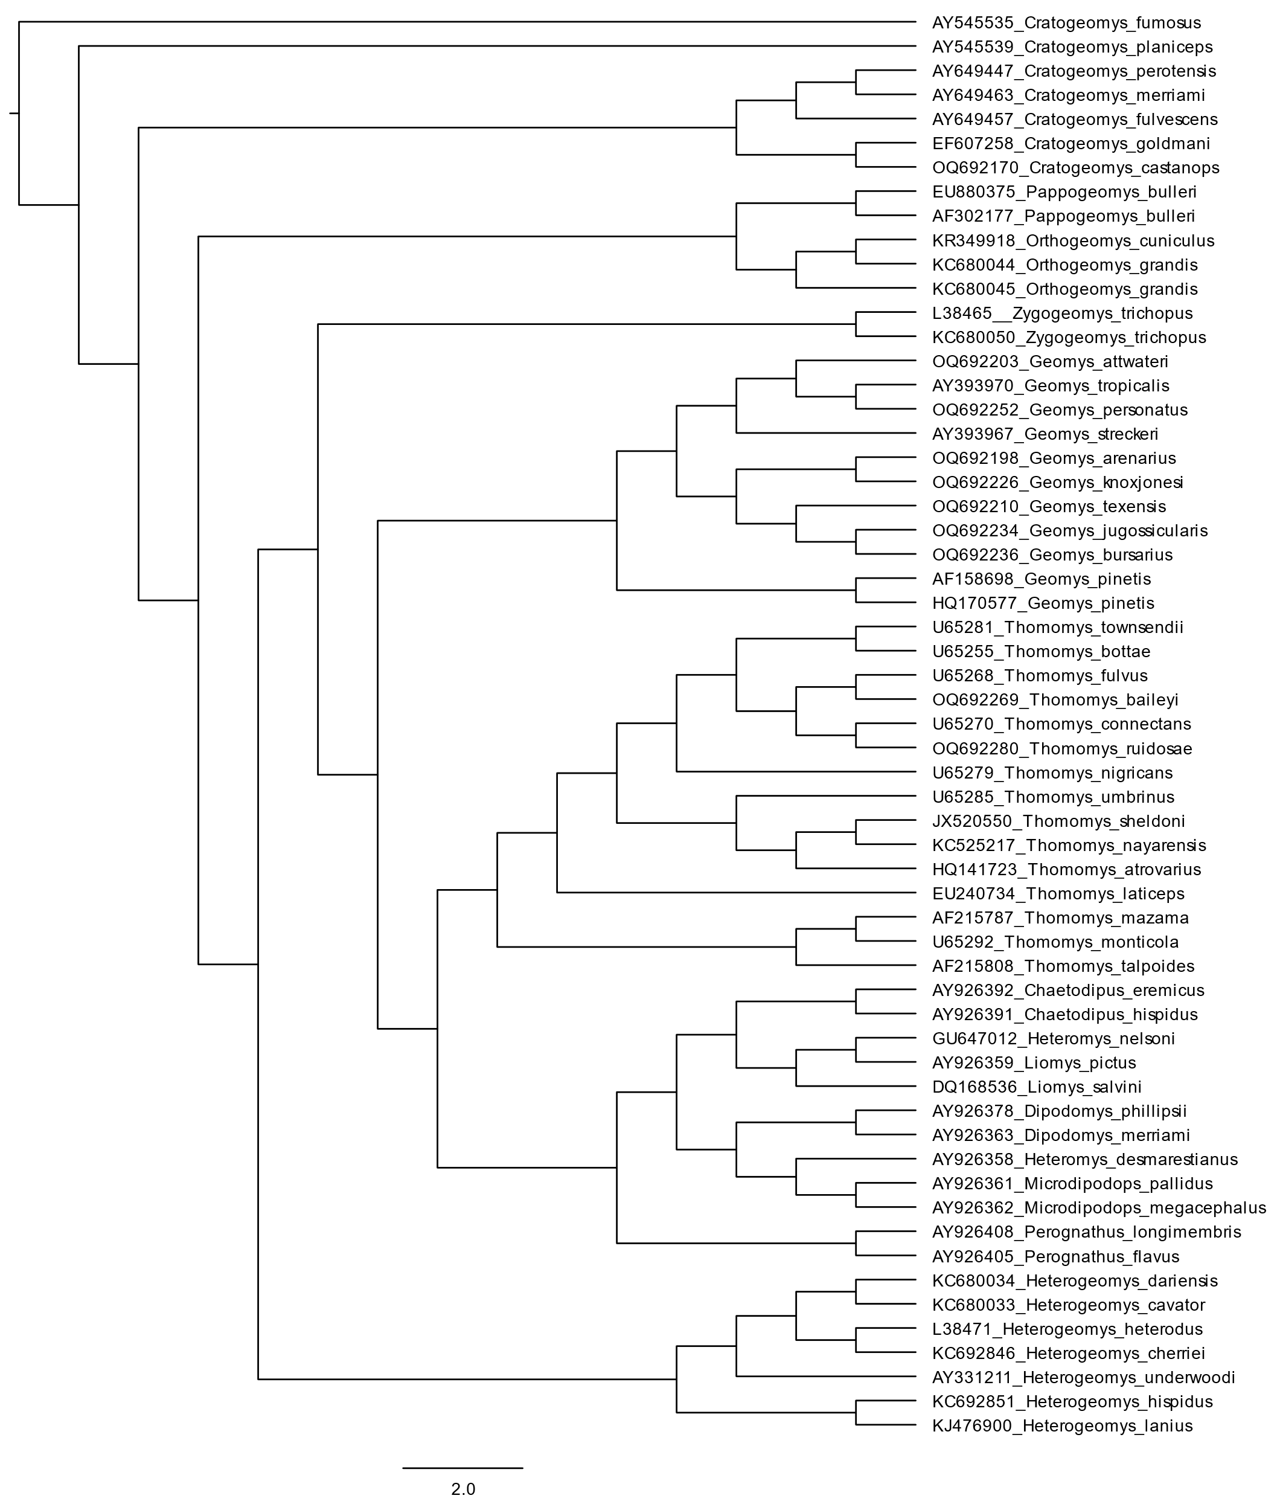

Cytochrome b neighbor-joining bootstrap consensus tree generating 100 pseudoreplicates.

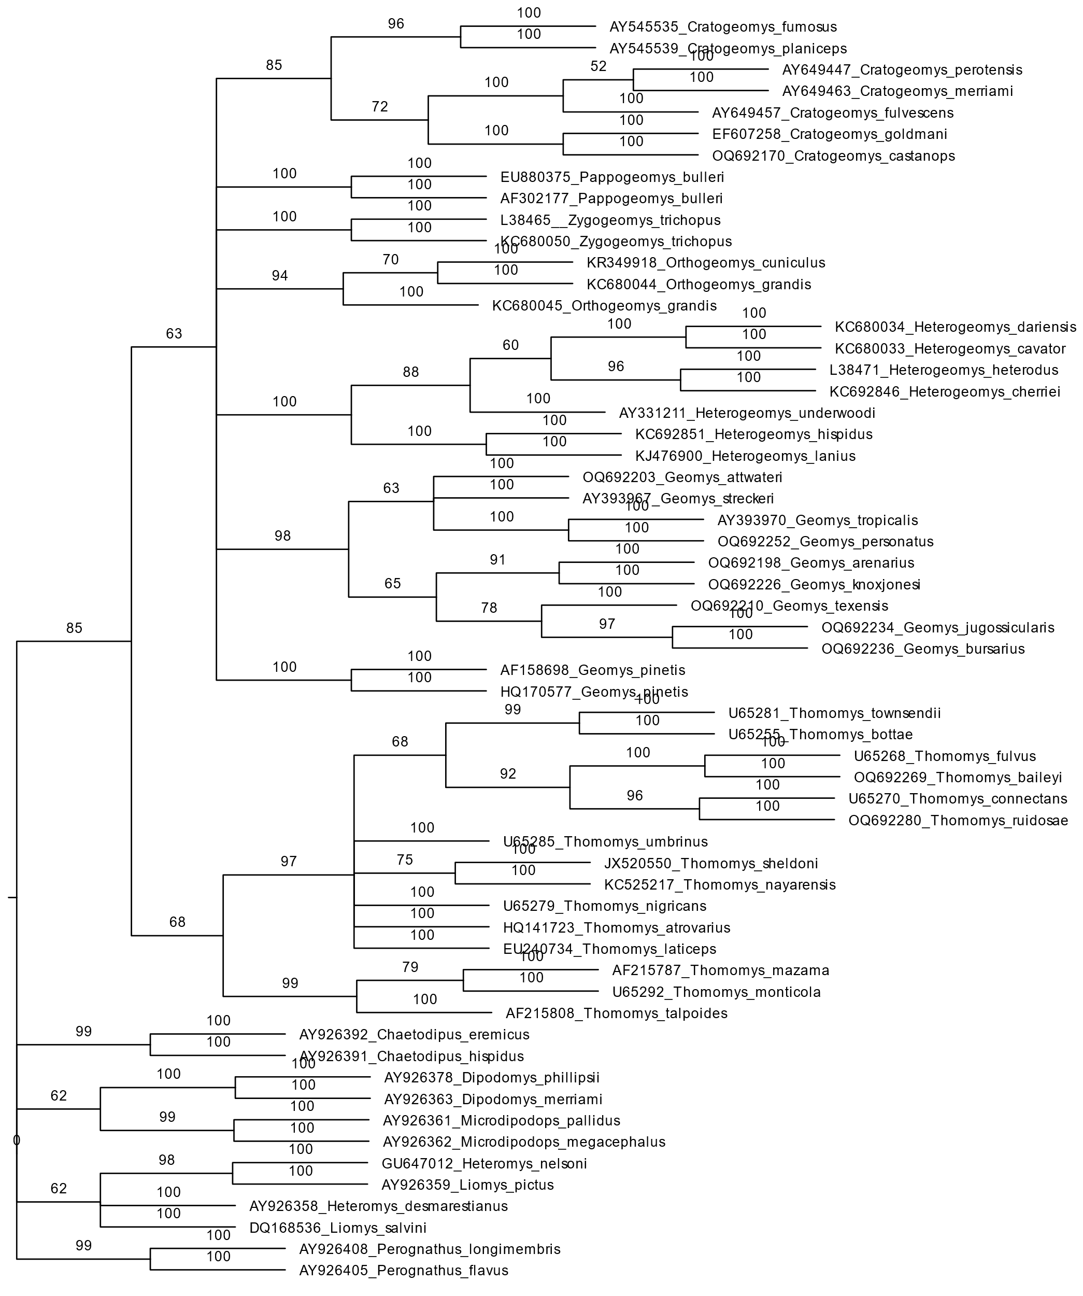

Cytochrome b unweighted pair group method with arithmetic mean.

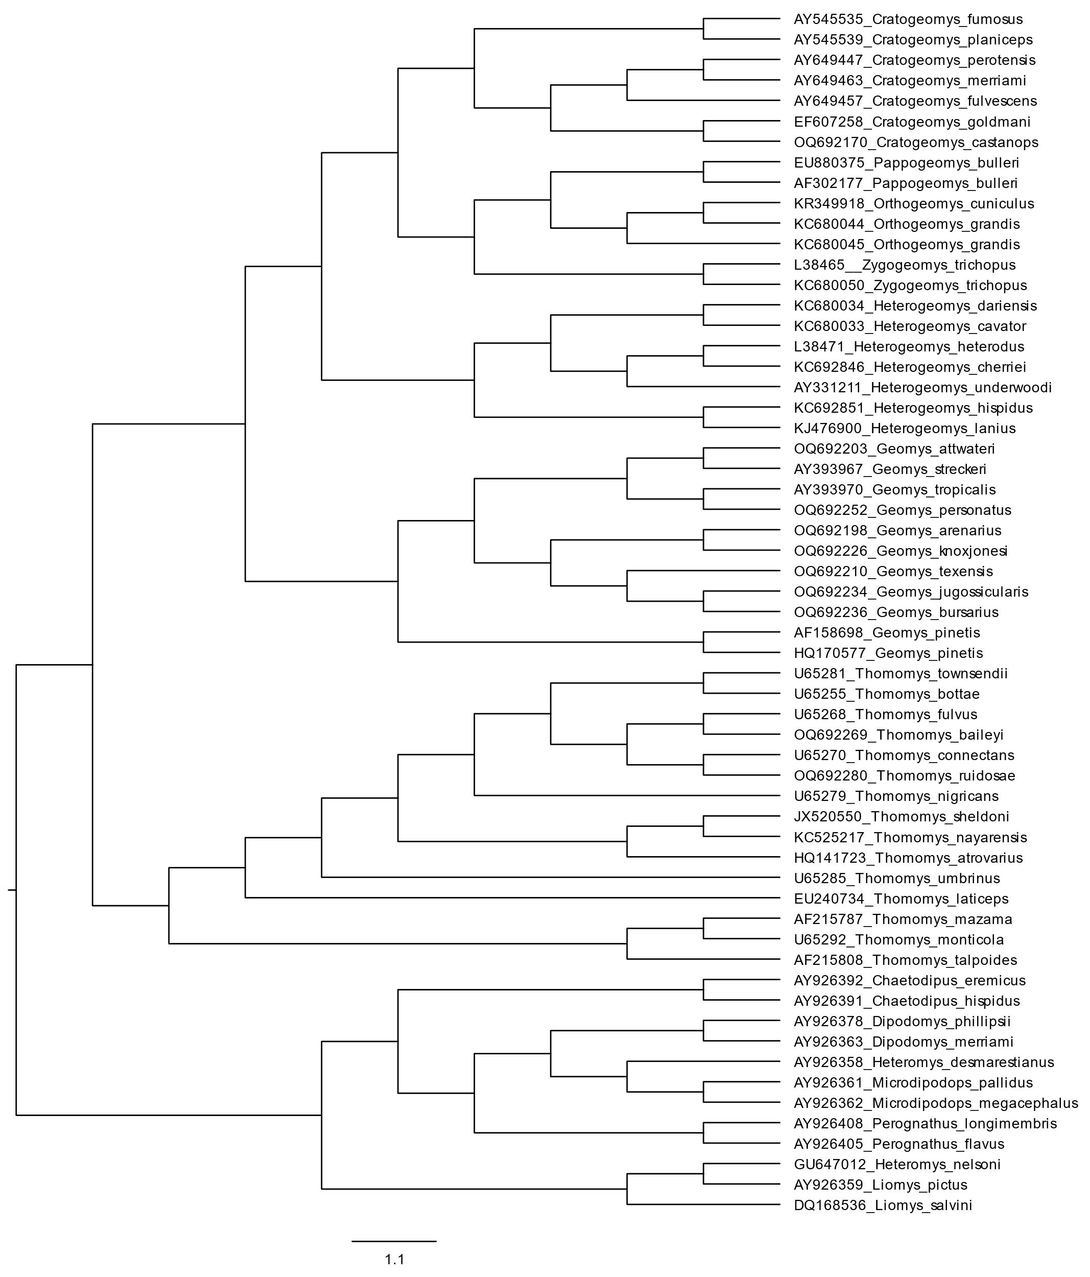

Cytochrome b unweighted pair group method with arithmetic mean bootstrap consensus tree generating 100 pseudoreplicates.

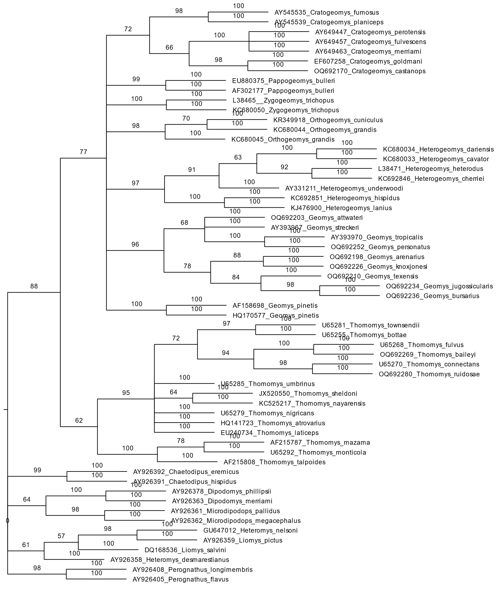

Cytochrome b maximum-parsimony.

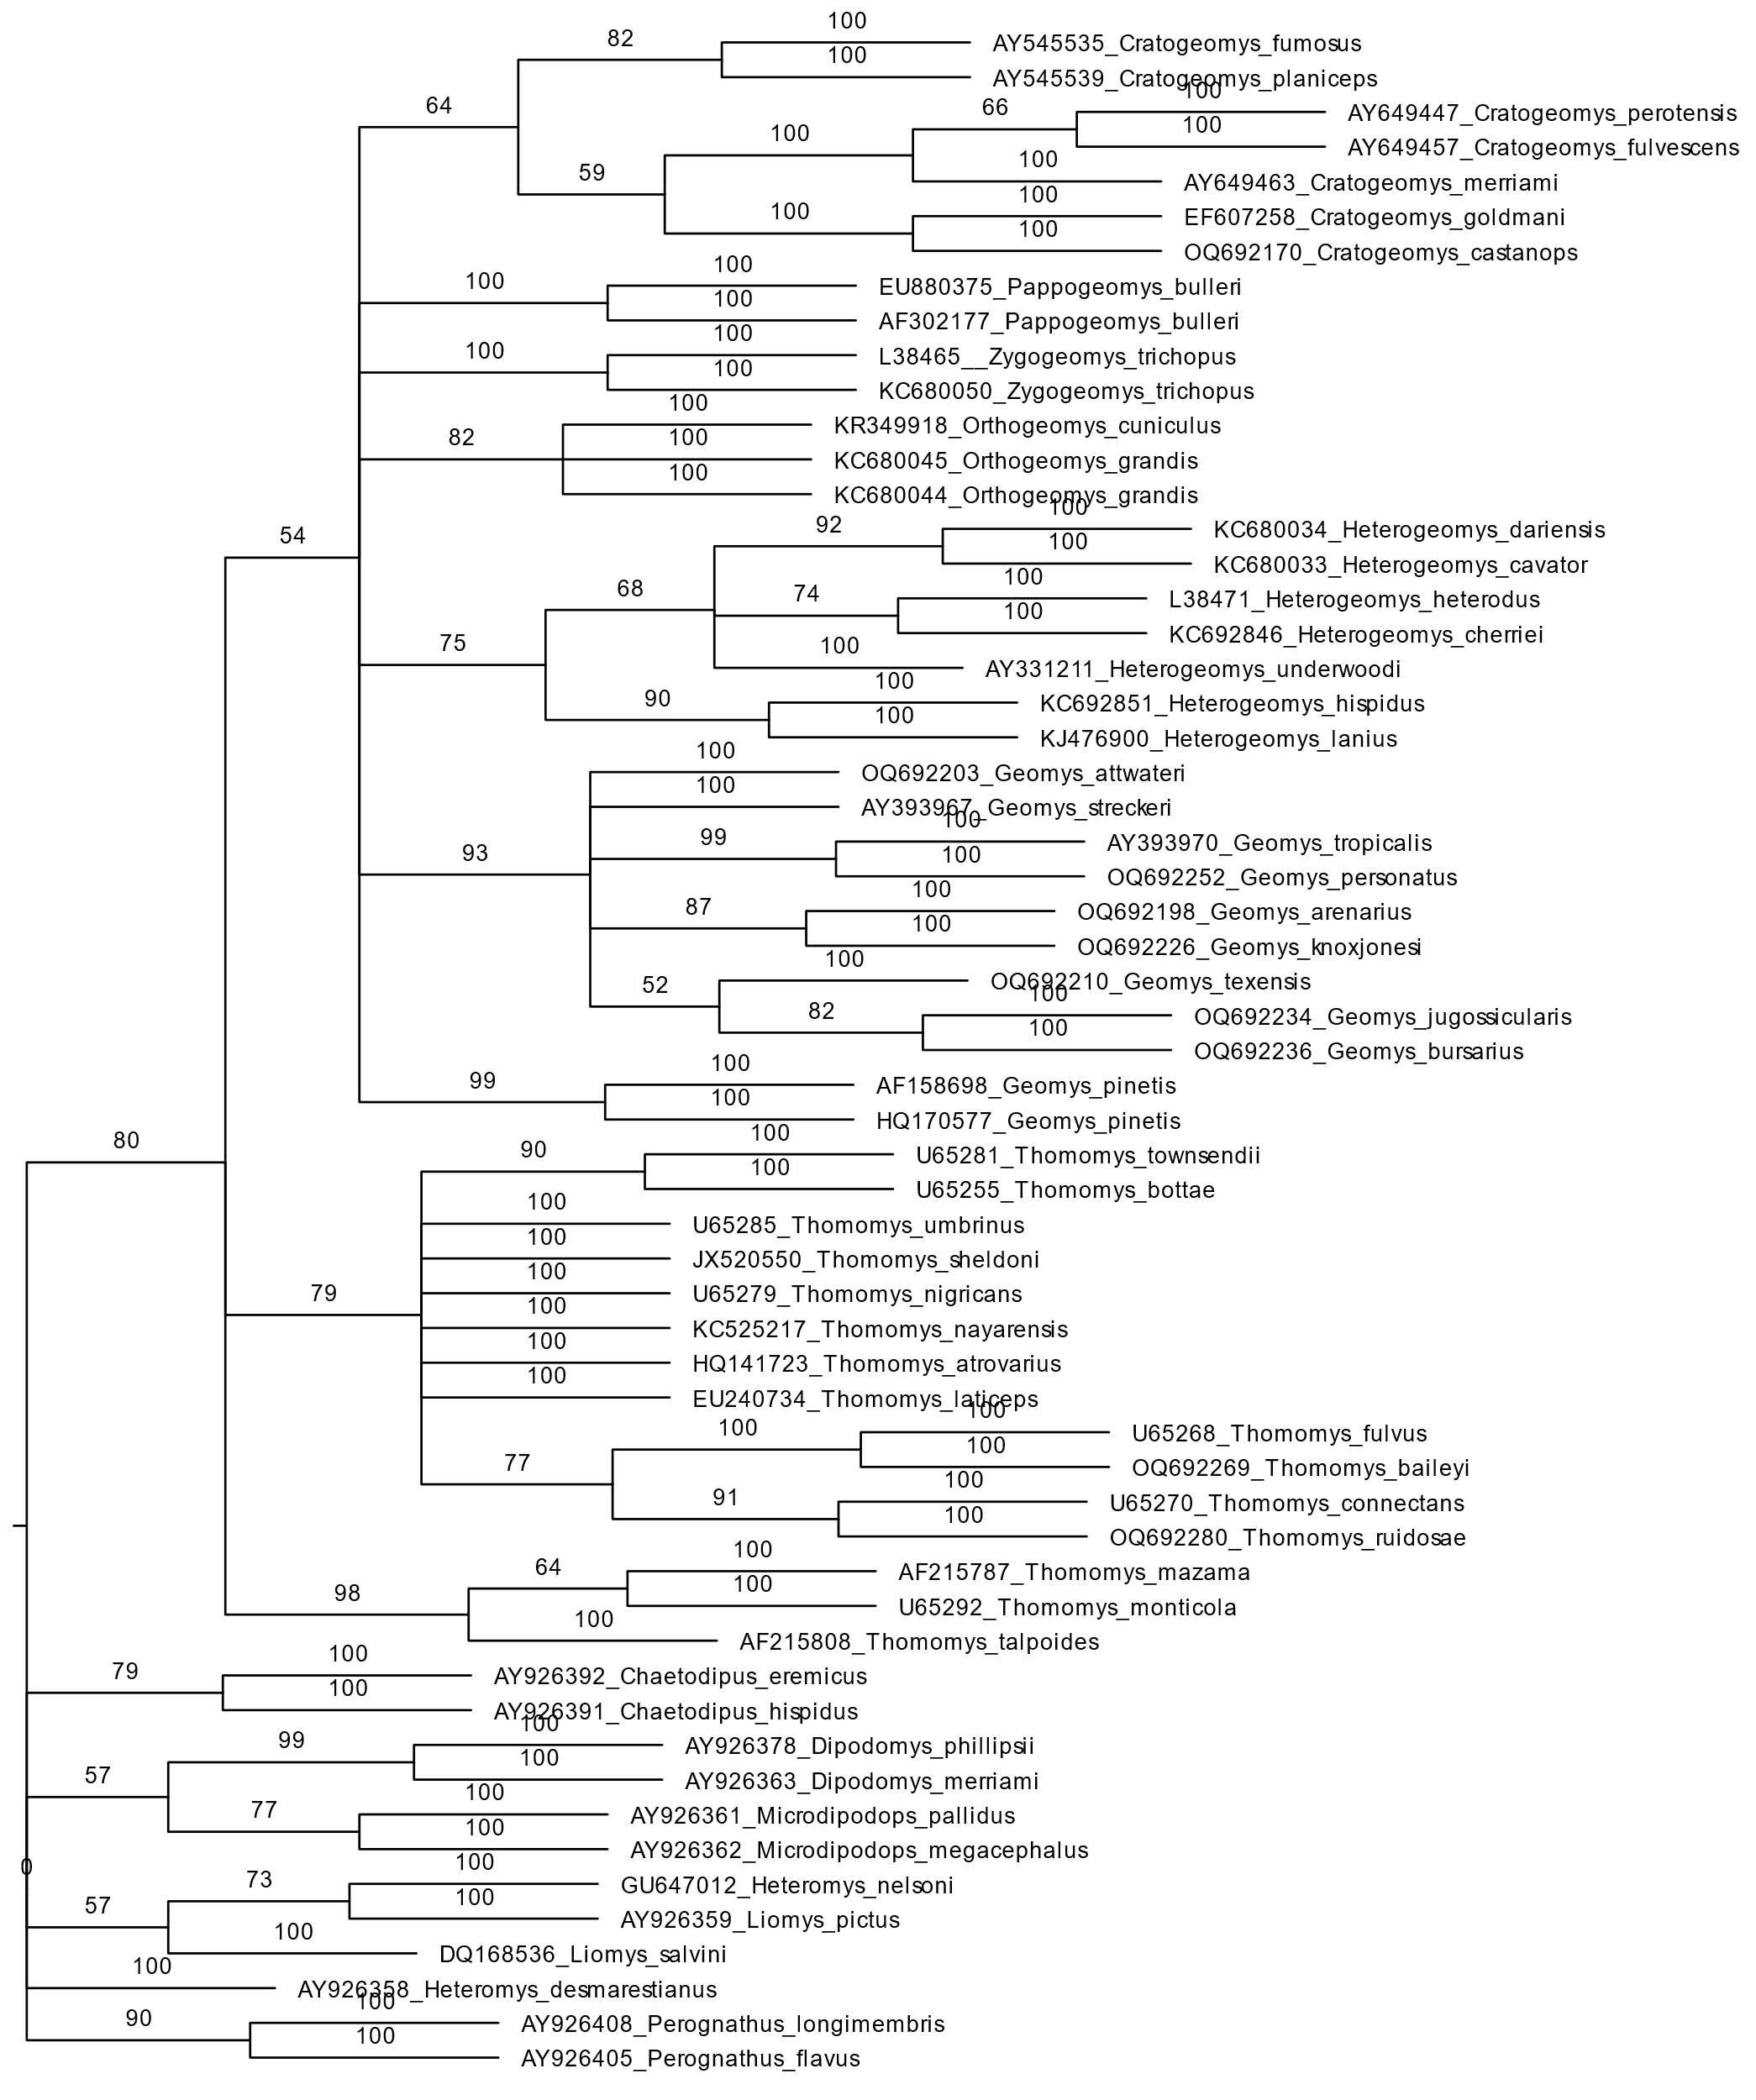

Cytochrome b maximum Likelihood method.

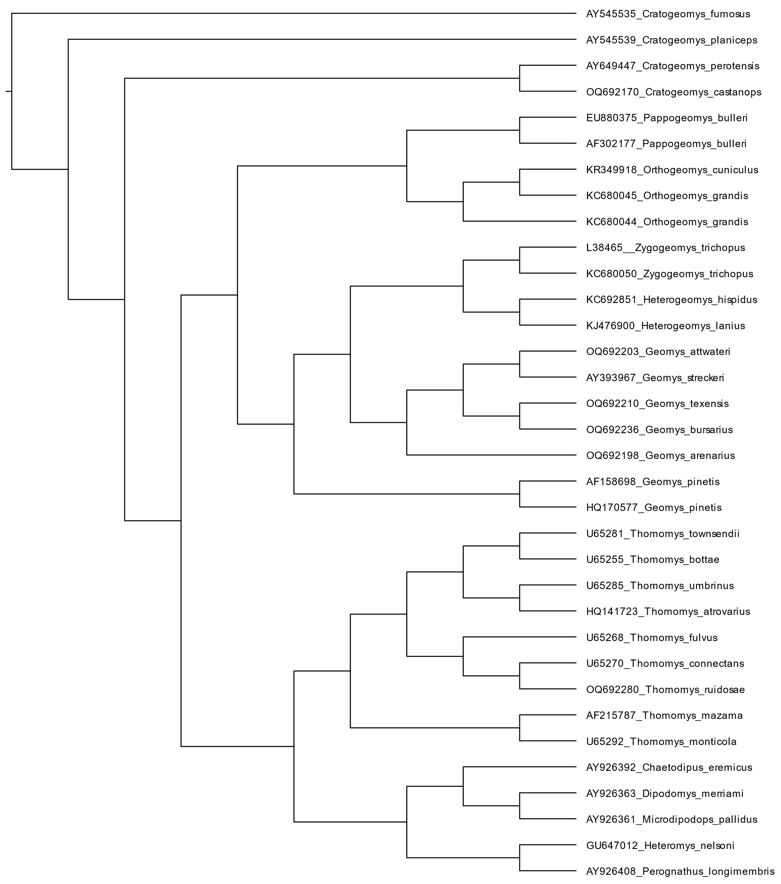

Cytochrome b Bayesian maxima probability.

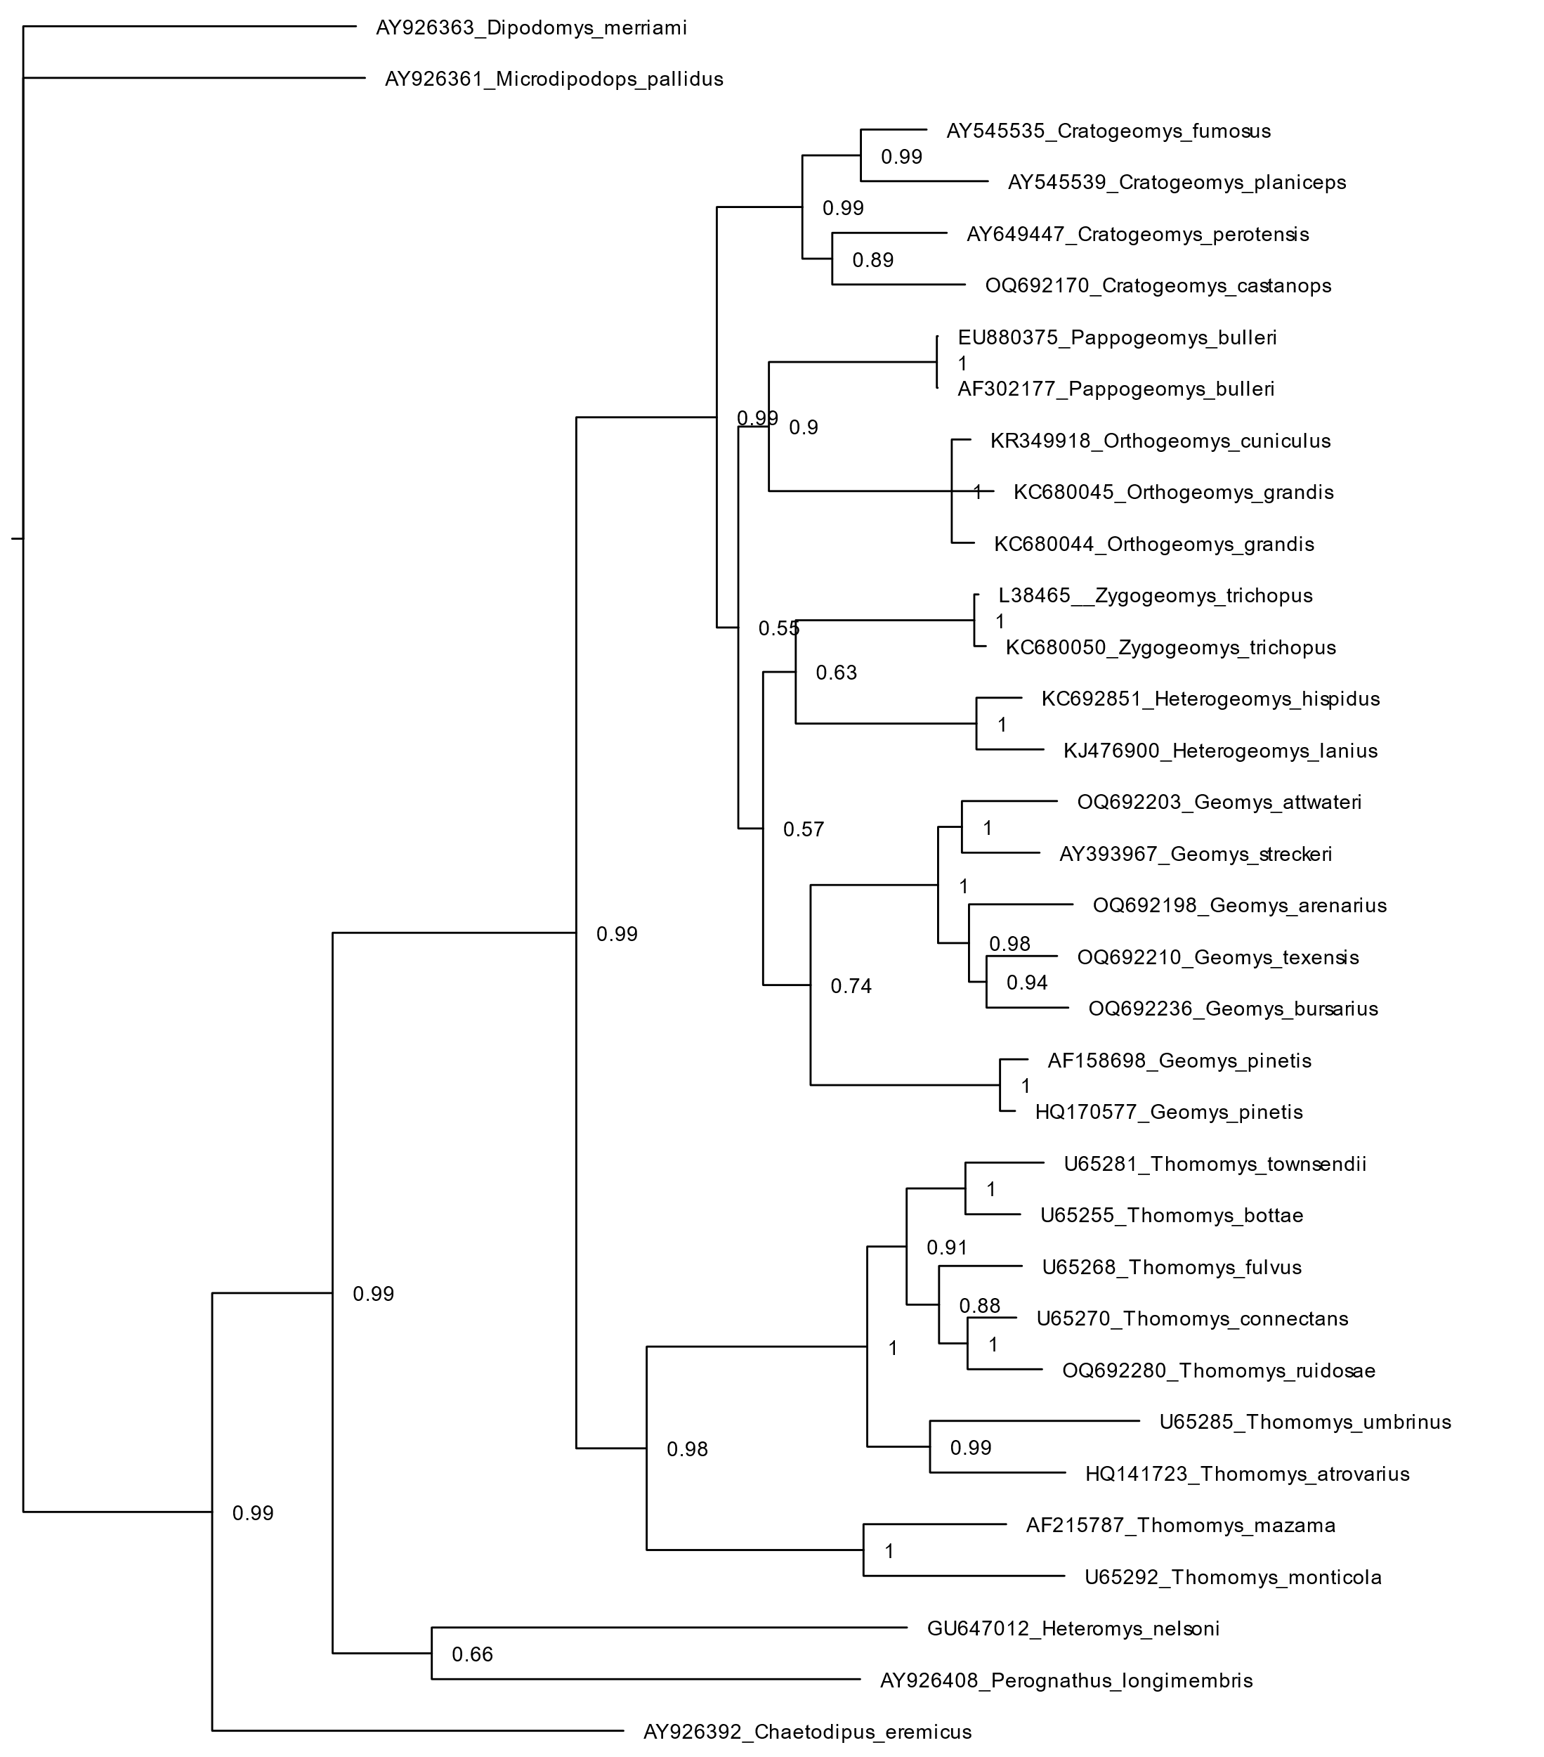

Cytochrome oxidase subunit 1 neighbor-joining bootstrap consensus tree generating 100 pseudoreplicates.

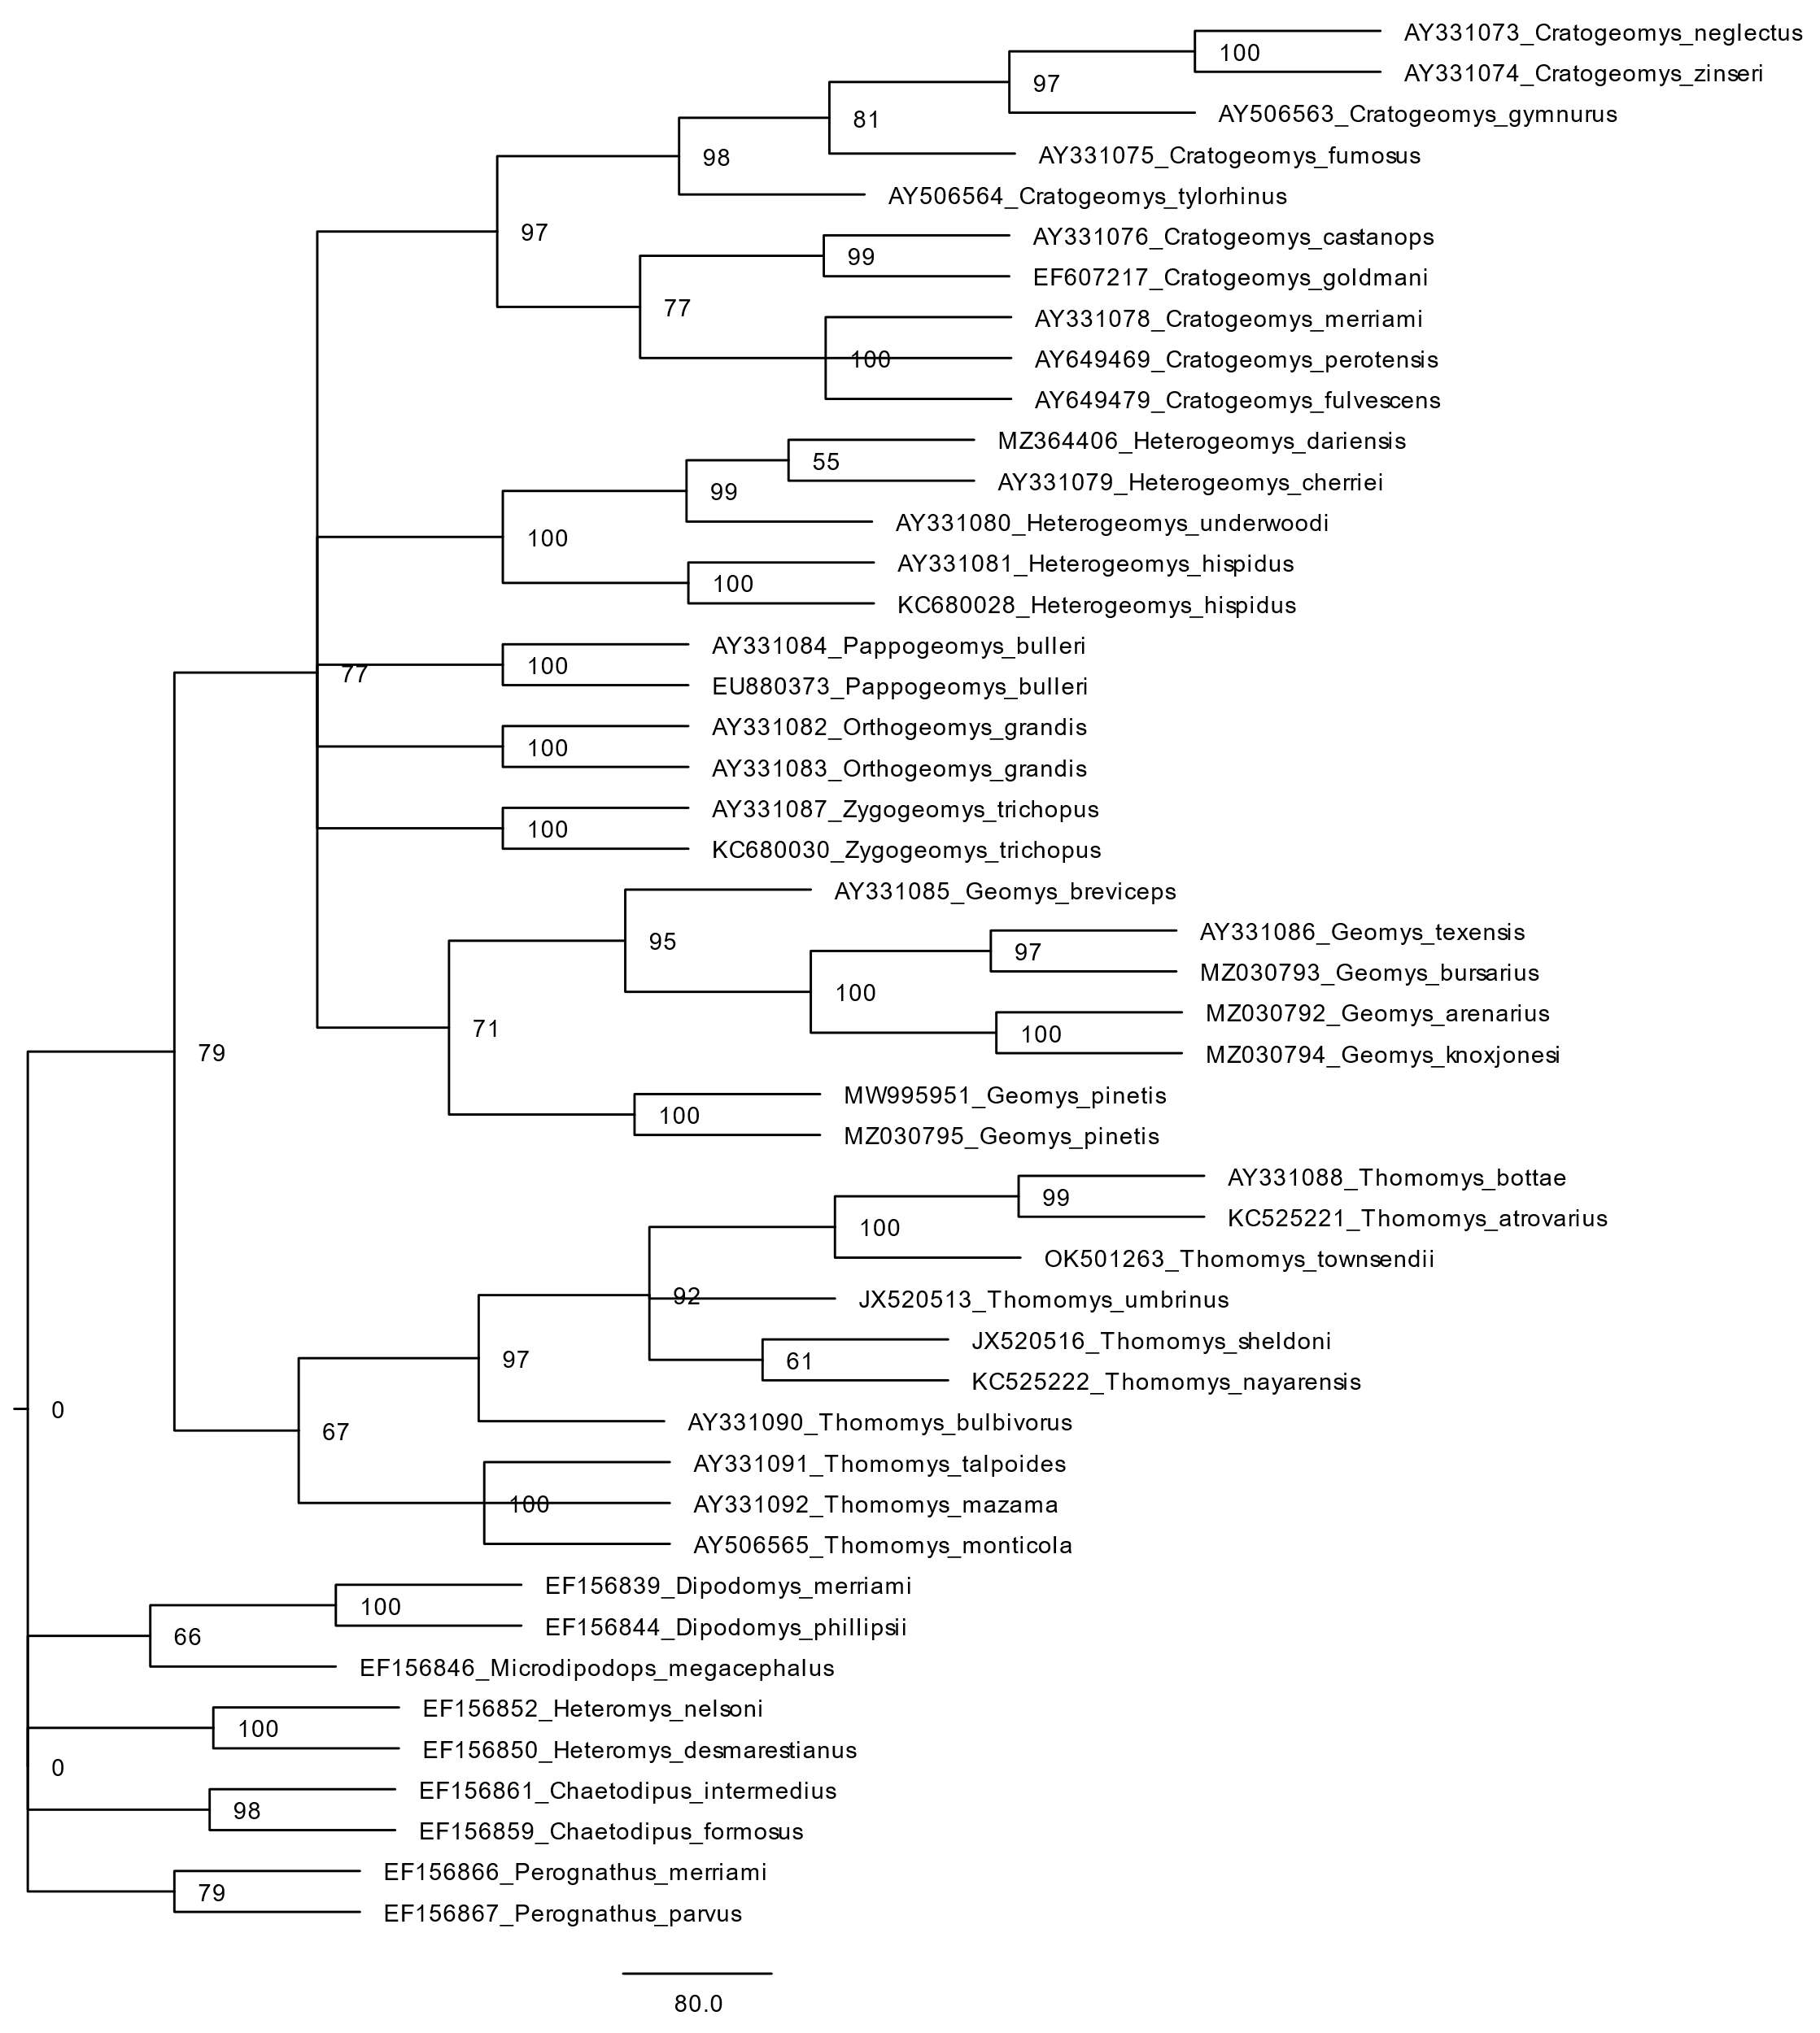

Cytochrome oxidase subunit 1 unweighted pair group method with arithmetic mean.

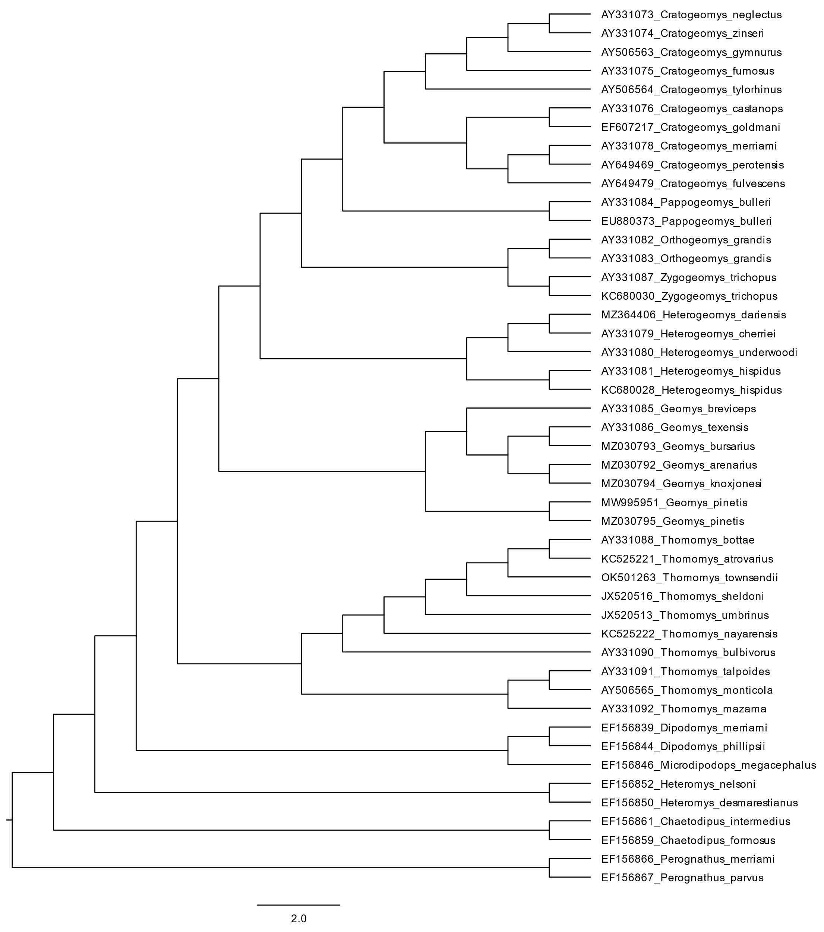

Cytochrome oxidase subunit 1 unweighted pair group method with arithmetic mean bootstrap consensus tree generating 100 pseudoreplicates.

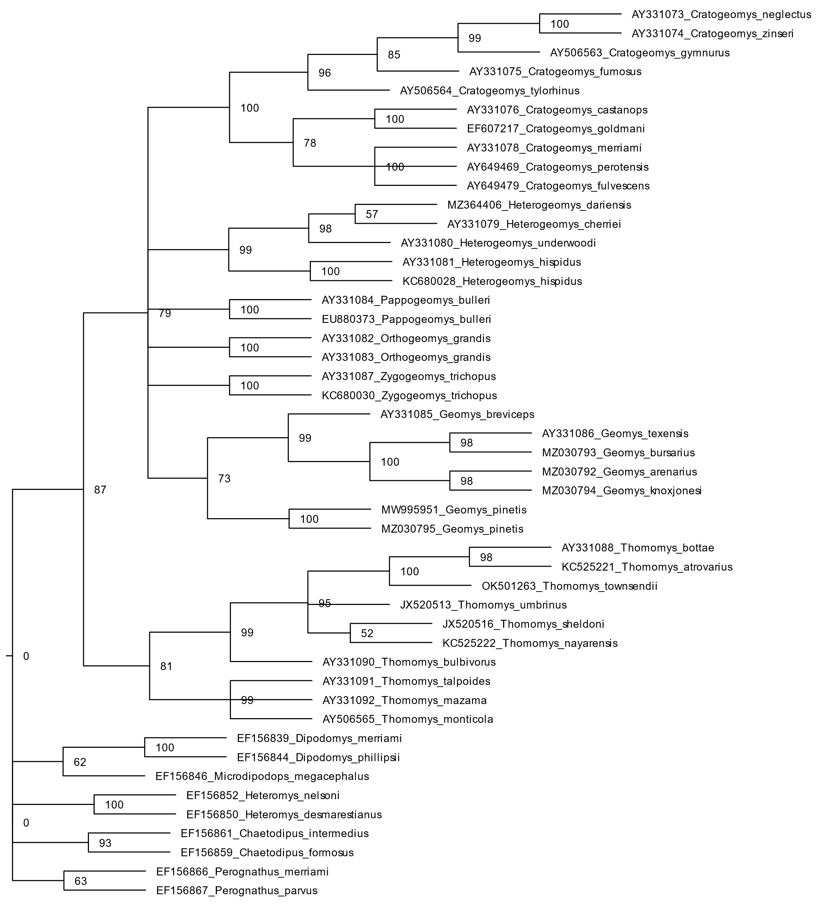

Cytochrome oxidase subunit 1 maximum-parsimony.

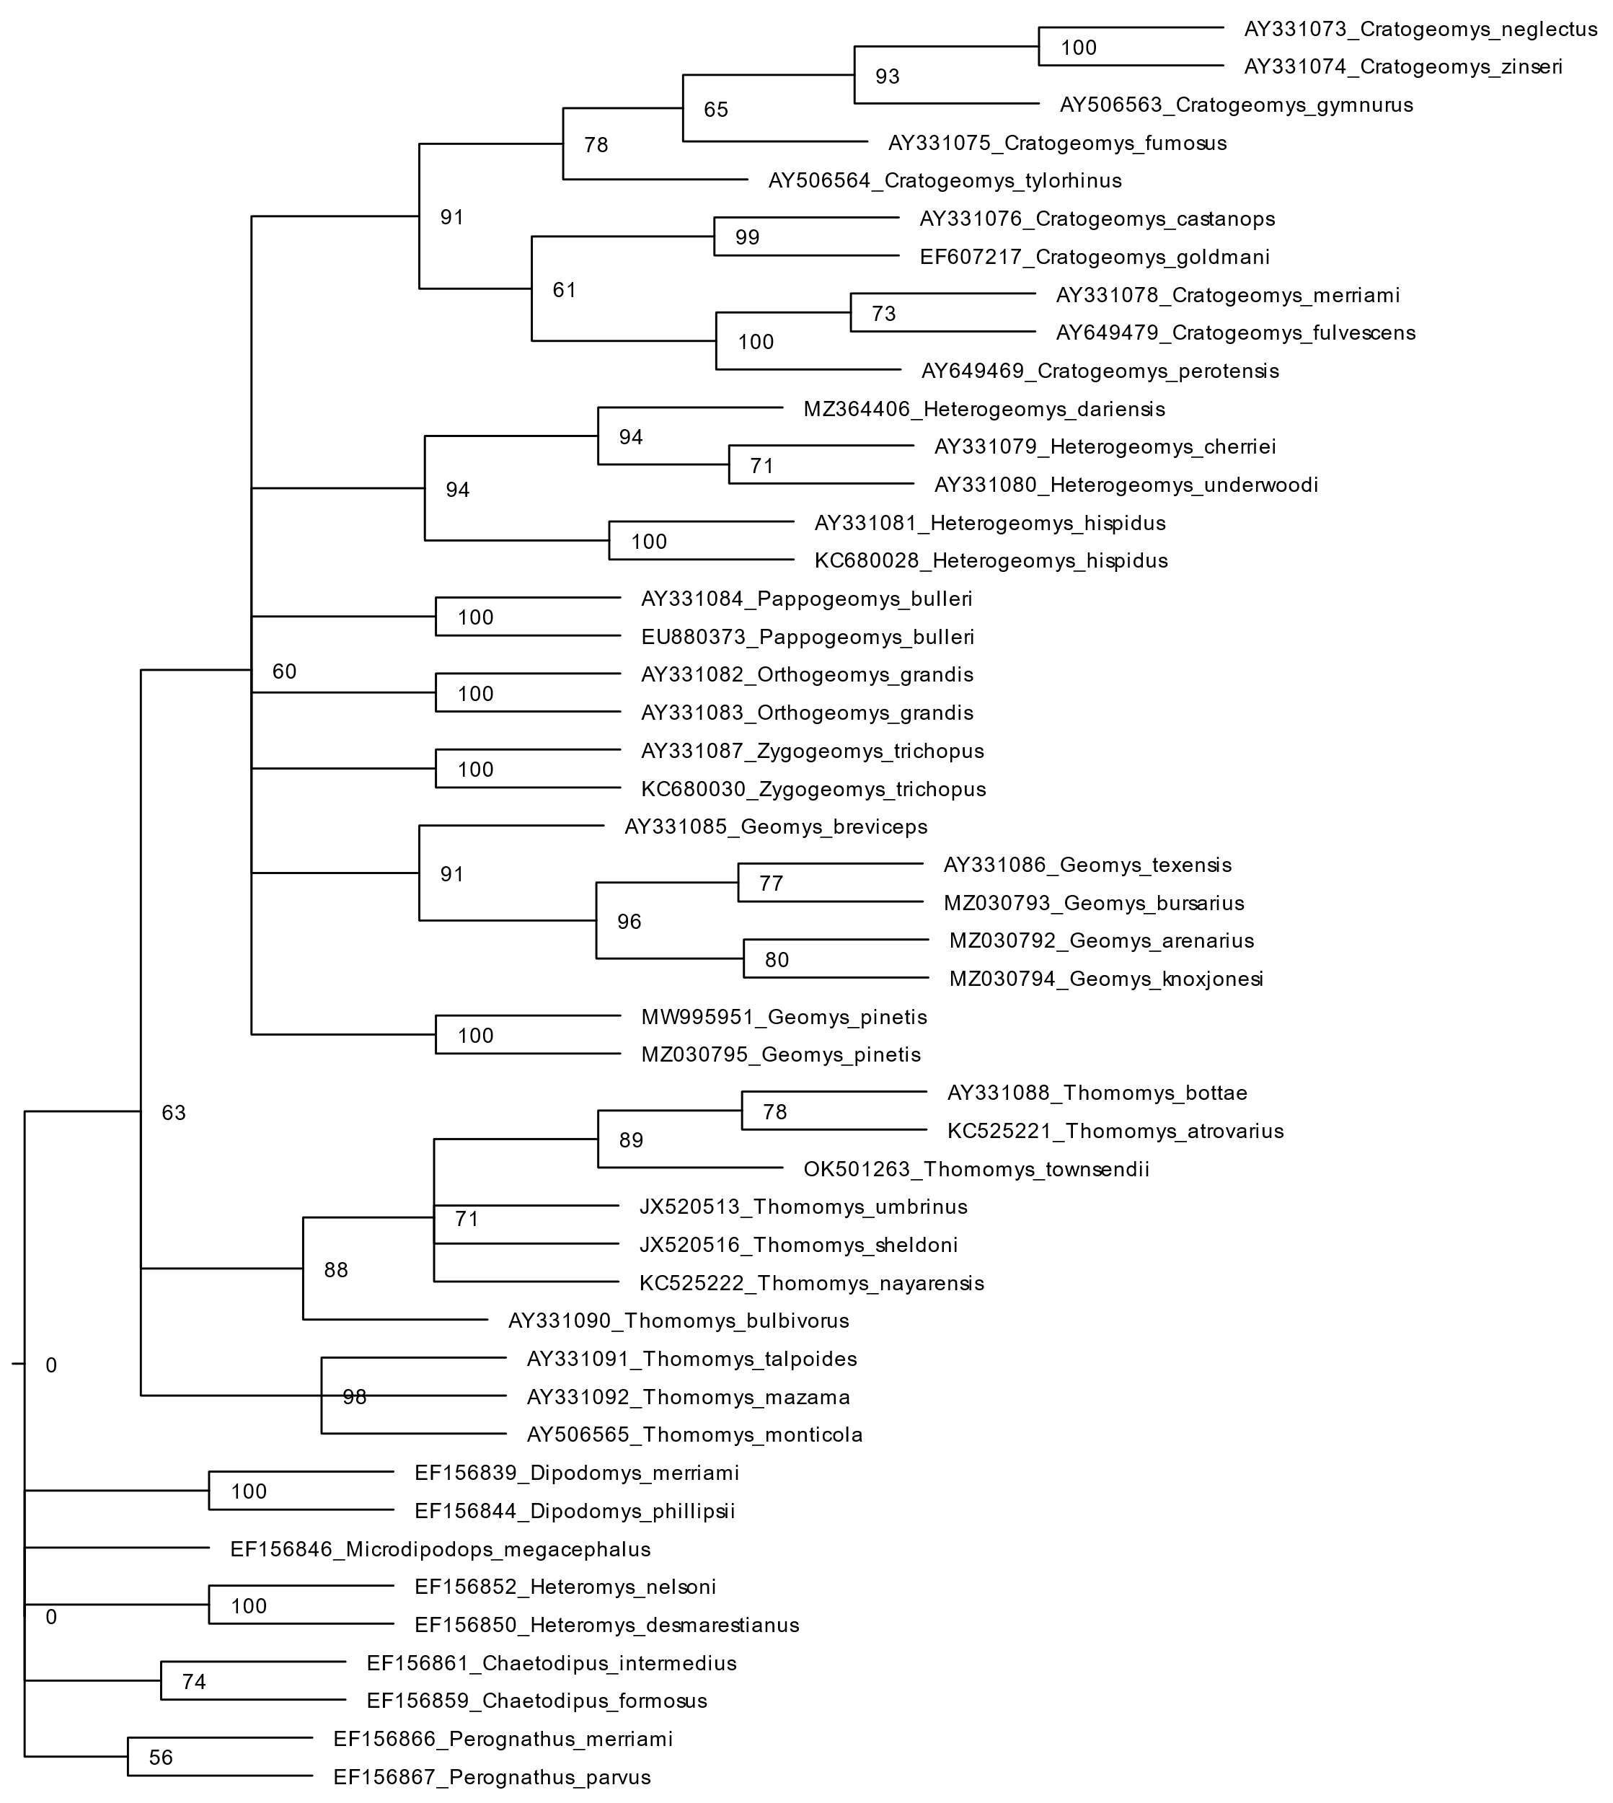

Cytochrome oxidase subunit 1 maximum Likelihood method.

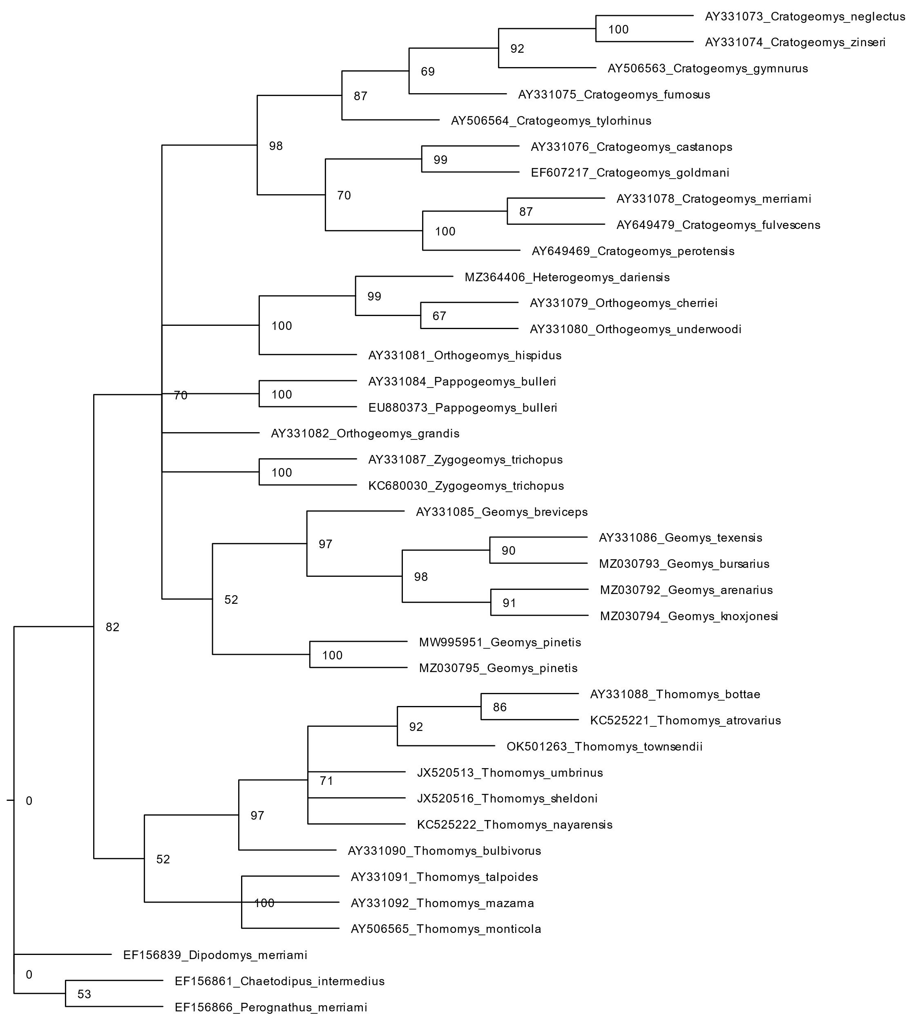

Cytochrome oxidase subunit 1 Bayesian maxima probability.

