Adams, A. L., et al. 2025. Wildlife disease surveillance from village to peak: Trypanosome infections of mammals on Sulawesi revealed higher prevalence in intact montane forests. Therya. DOI:10.12933/therya-25-6154.
Supplementary material 1

Microscope photos of detected trypanosomes among erythrocytes at x1000 magnification (unless stated otherwise) from 15-minute scans of a random sub-set of rodent and shrew blood smears collected from Sulawesi and stained using a 10% Giemsa solution.

Cruzi clade trypanosomes:
Cruzi clade trypanosome – HH 1136, Maxomys hellwaldii (x400 magnification)
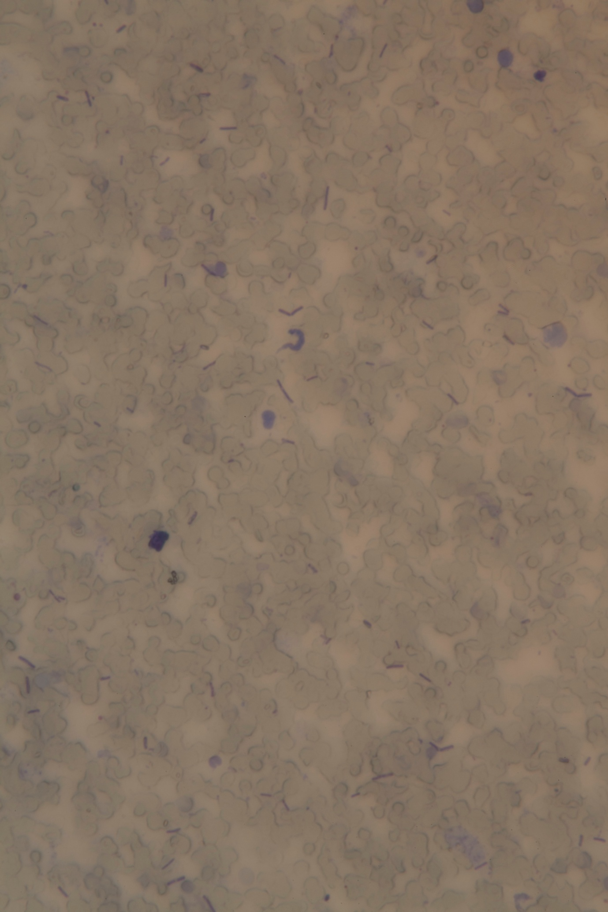

Lewisi clade trypanosomes:

Lewisi clade trypanosome – HH 1214, Bunomys penitus
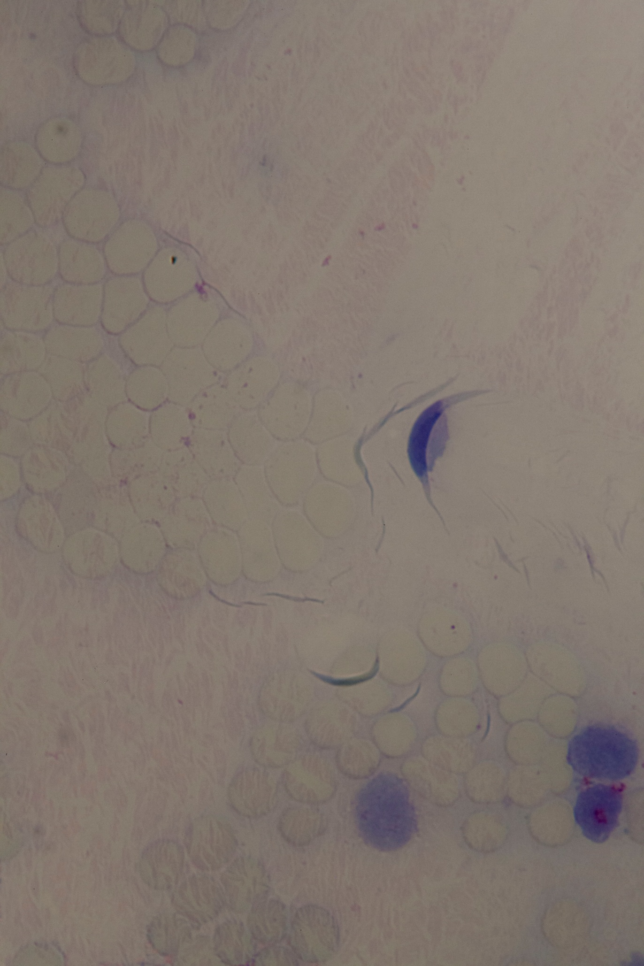
Lewisi clade trypanosome – KCR 3081, Bunomys chrysocomus
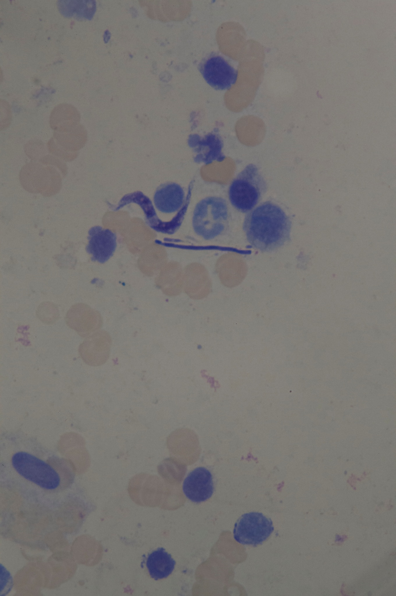

Lewisi clade trypanosome – KCR 3210, Bunomys chrysocomus
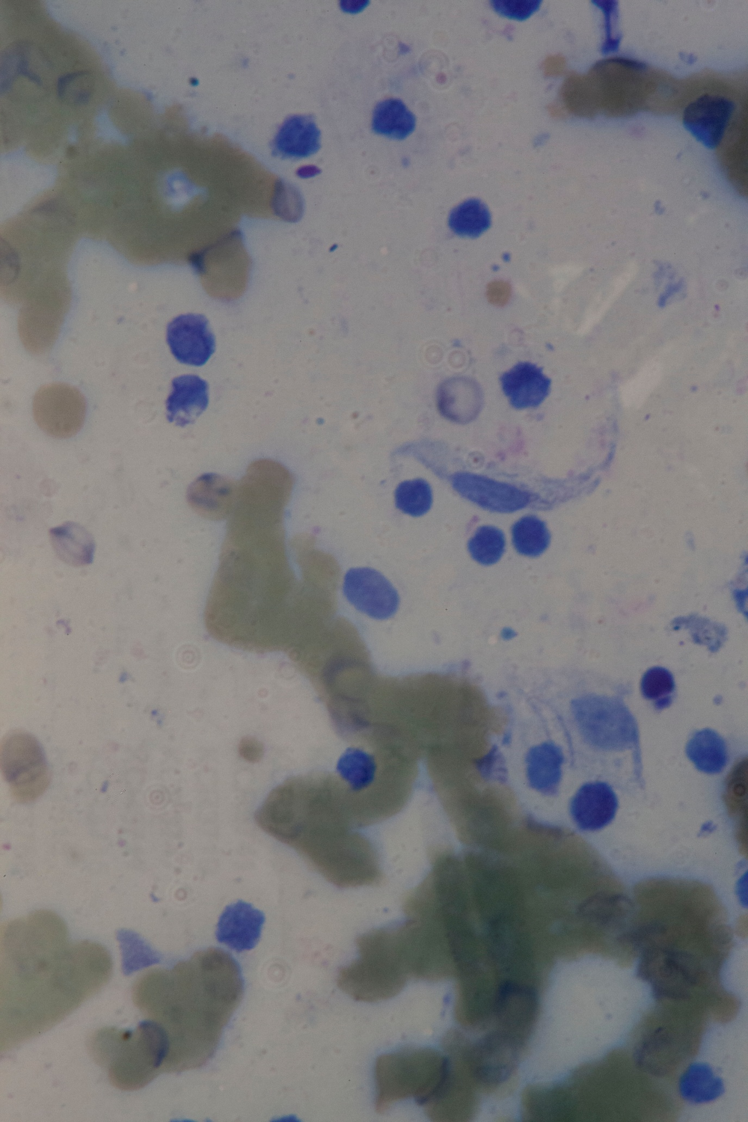

Theileri clade (T. cyclops) trypanosomes:
Theileri clade (T. cyclops) trypanosome – HH 1156, Maxomys musschenbroekii
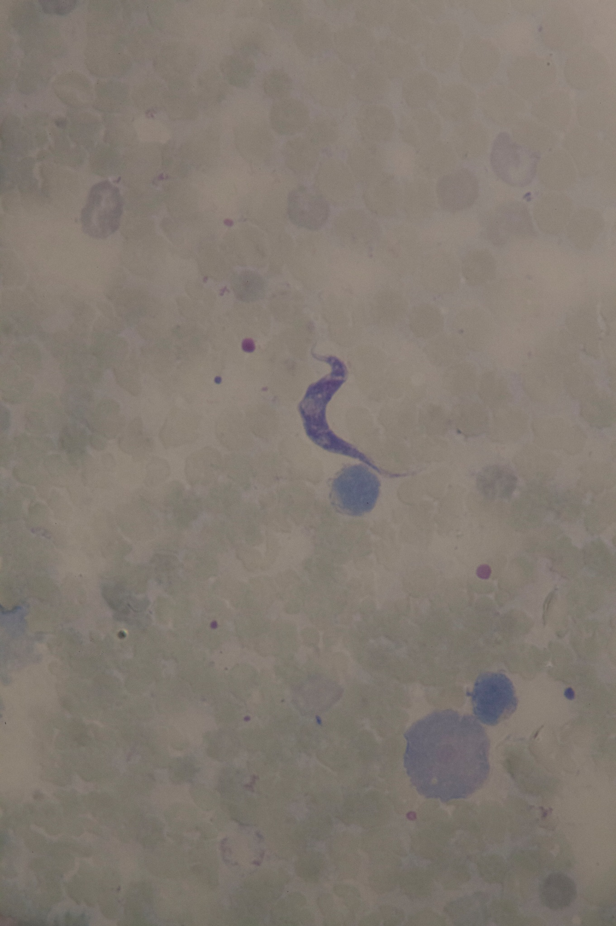

Theileri clade (T. cyclops) trypanosome – HH 1501, Crocidura elongata
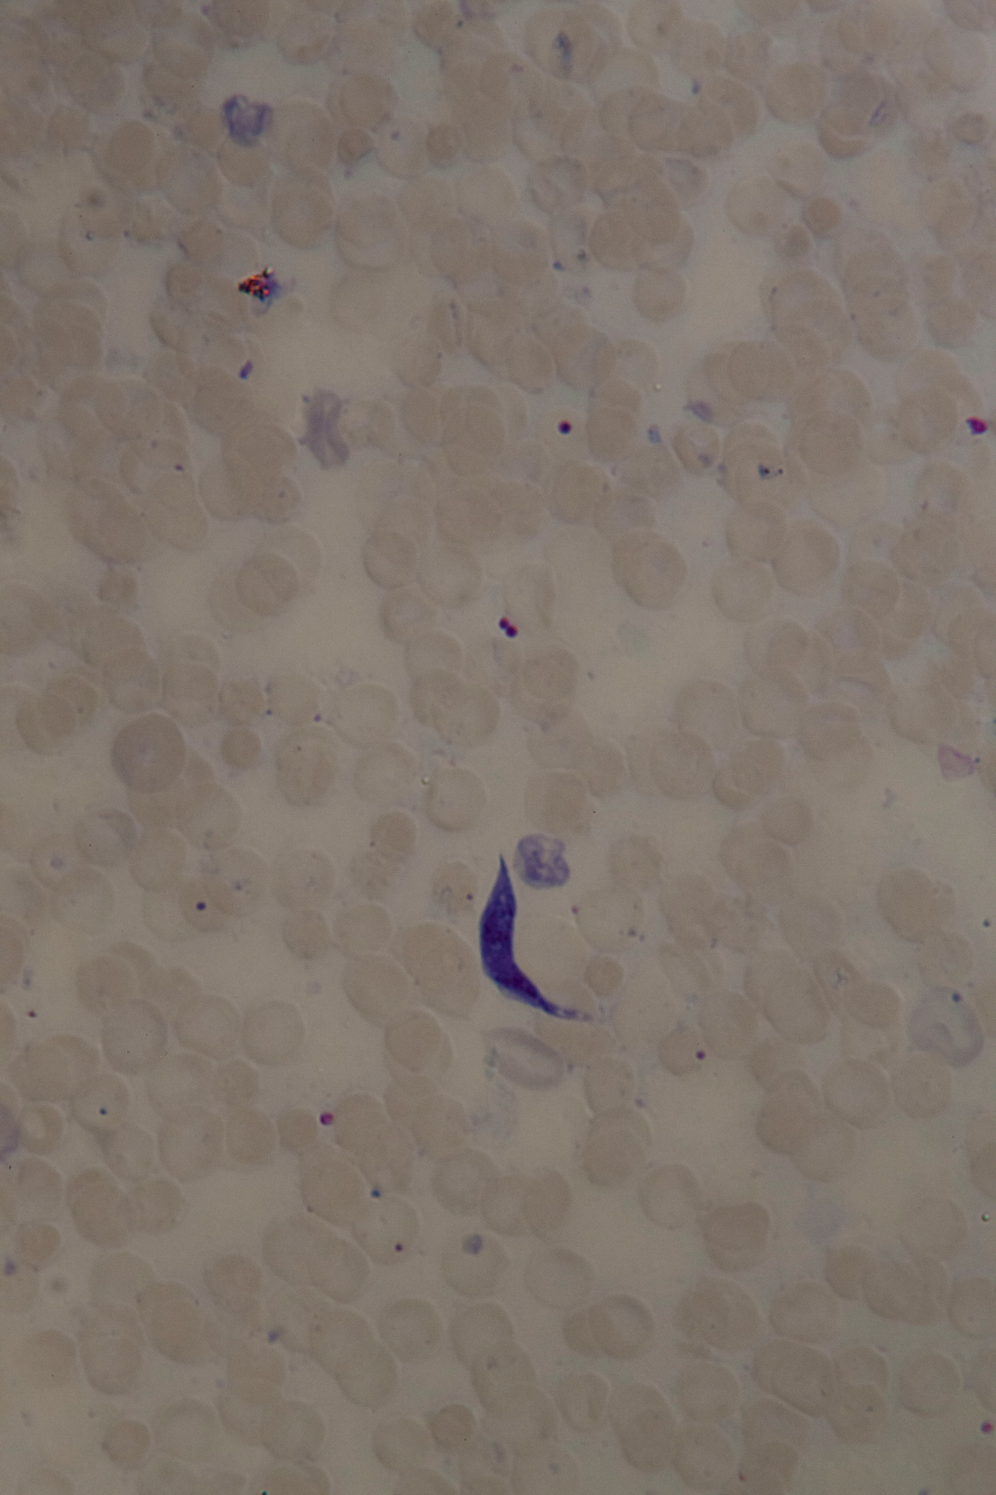
Theileri clade (T. cyclops) trypanosome – HH 1505, Crocidura pseudorhoditis
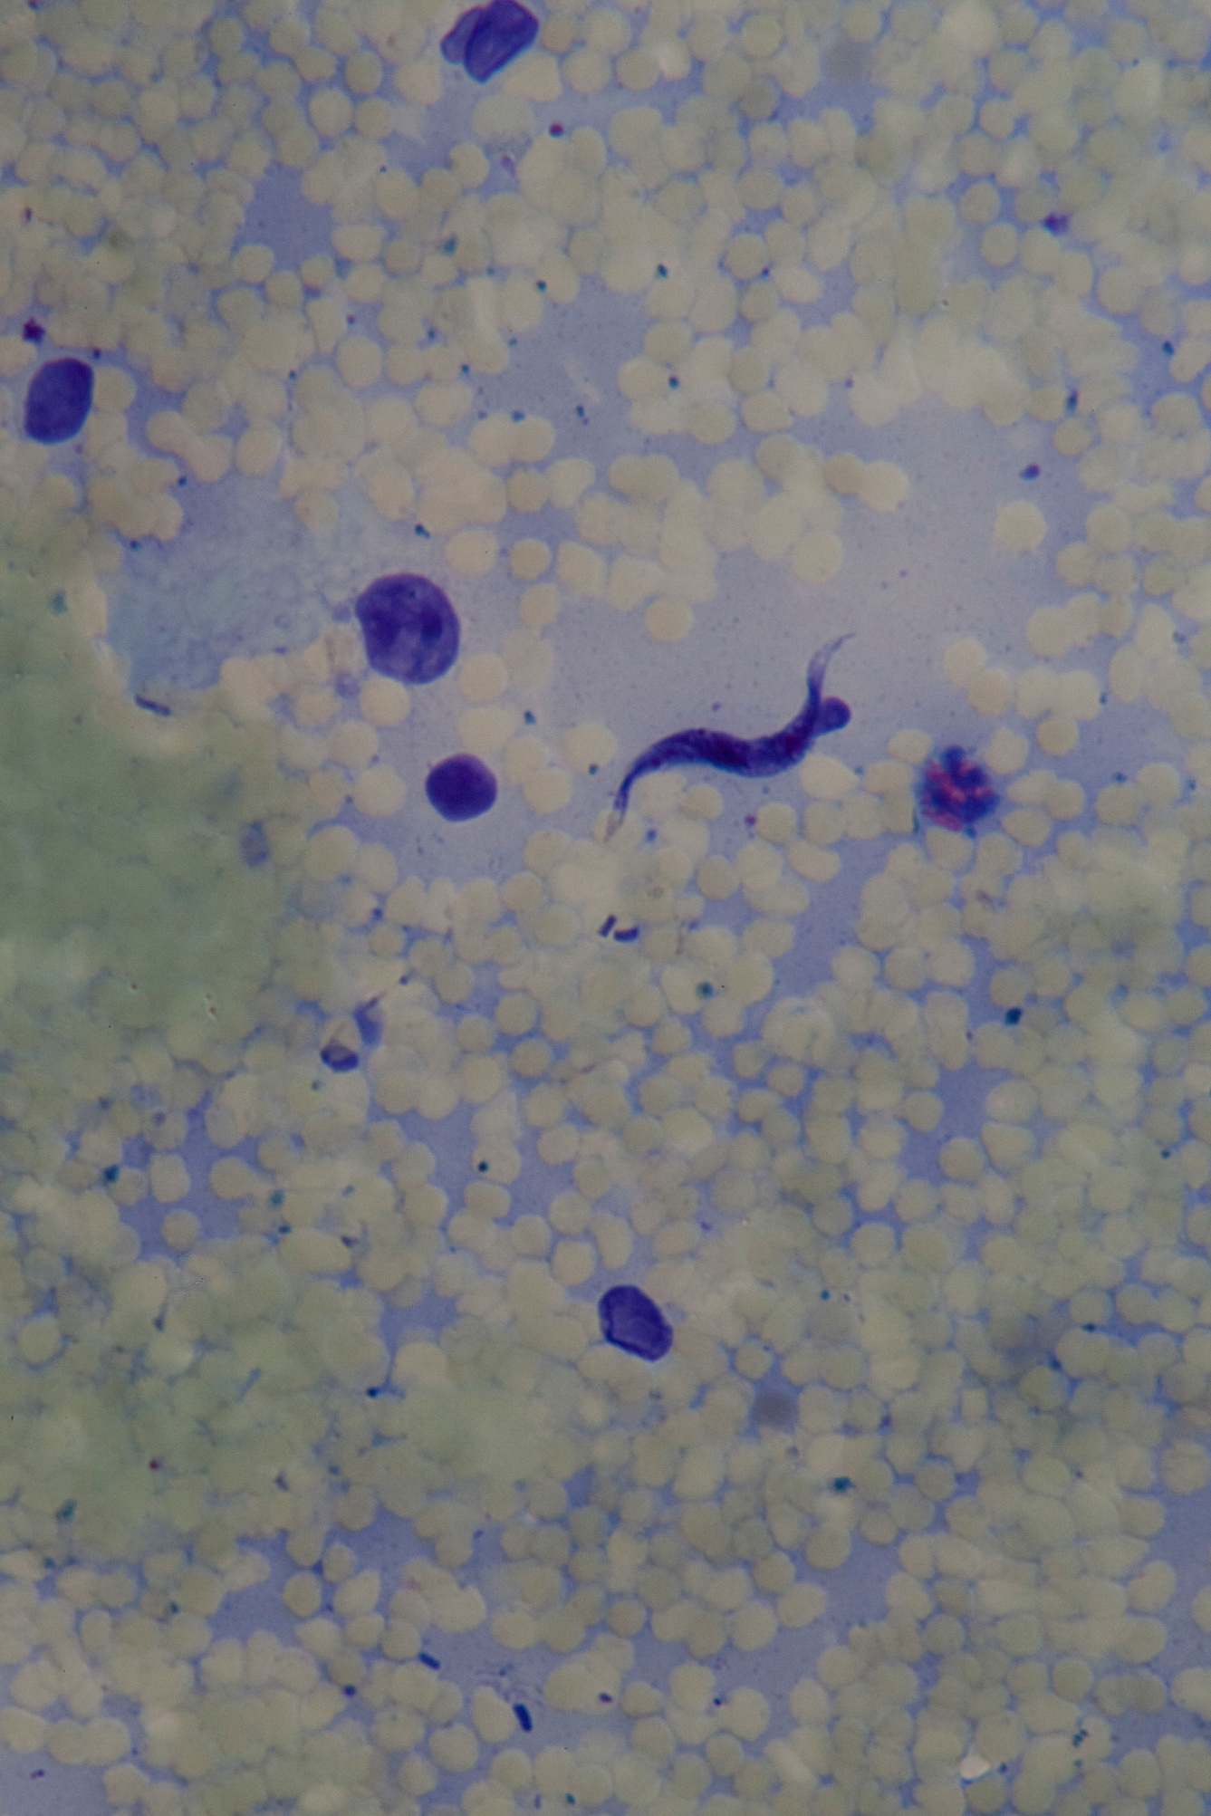

Theileri clade (T. cyclops) trypanosome – HH 1516, Maxomys musschenbroekii
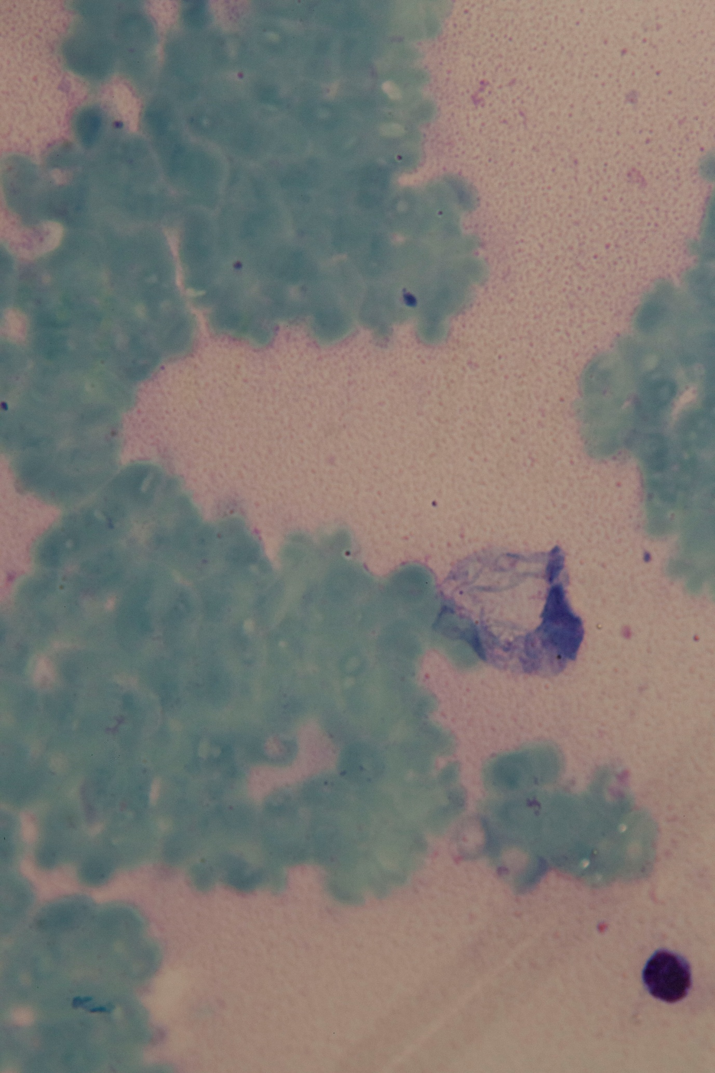
Theileri clade (T. cyclops) trypanosome – KCR 3065, Bunomys chrysocomus
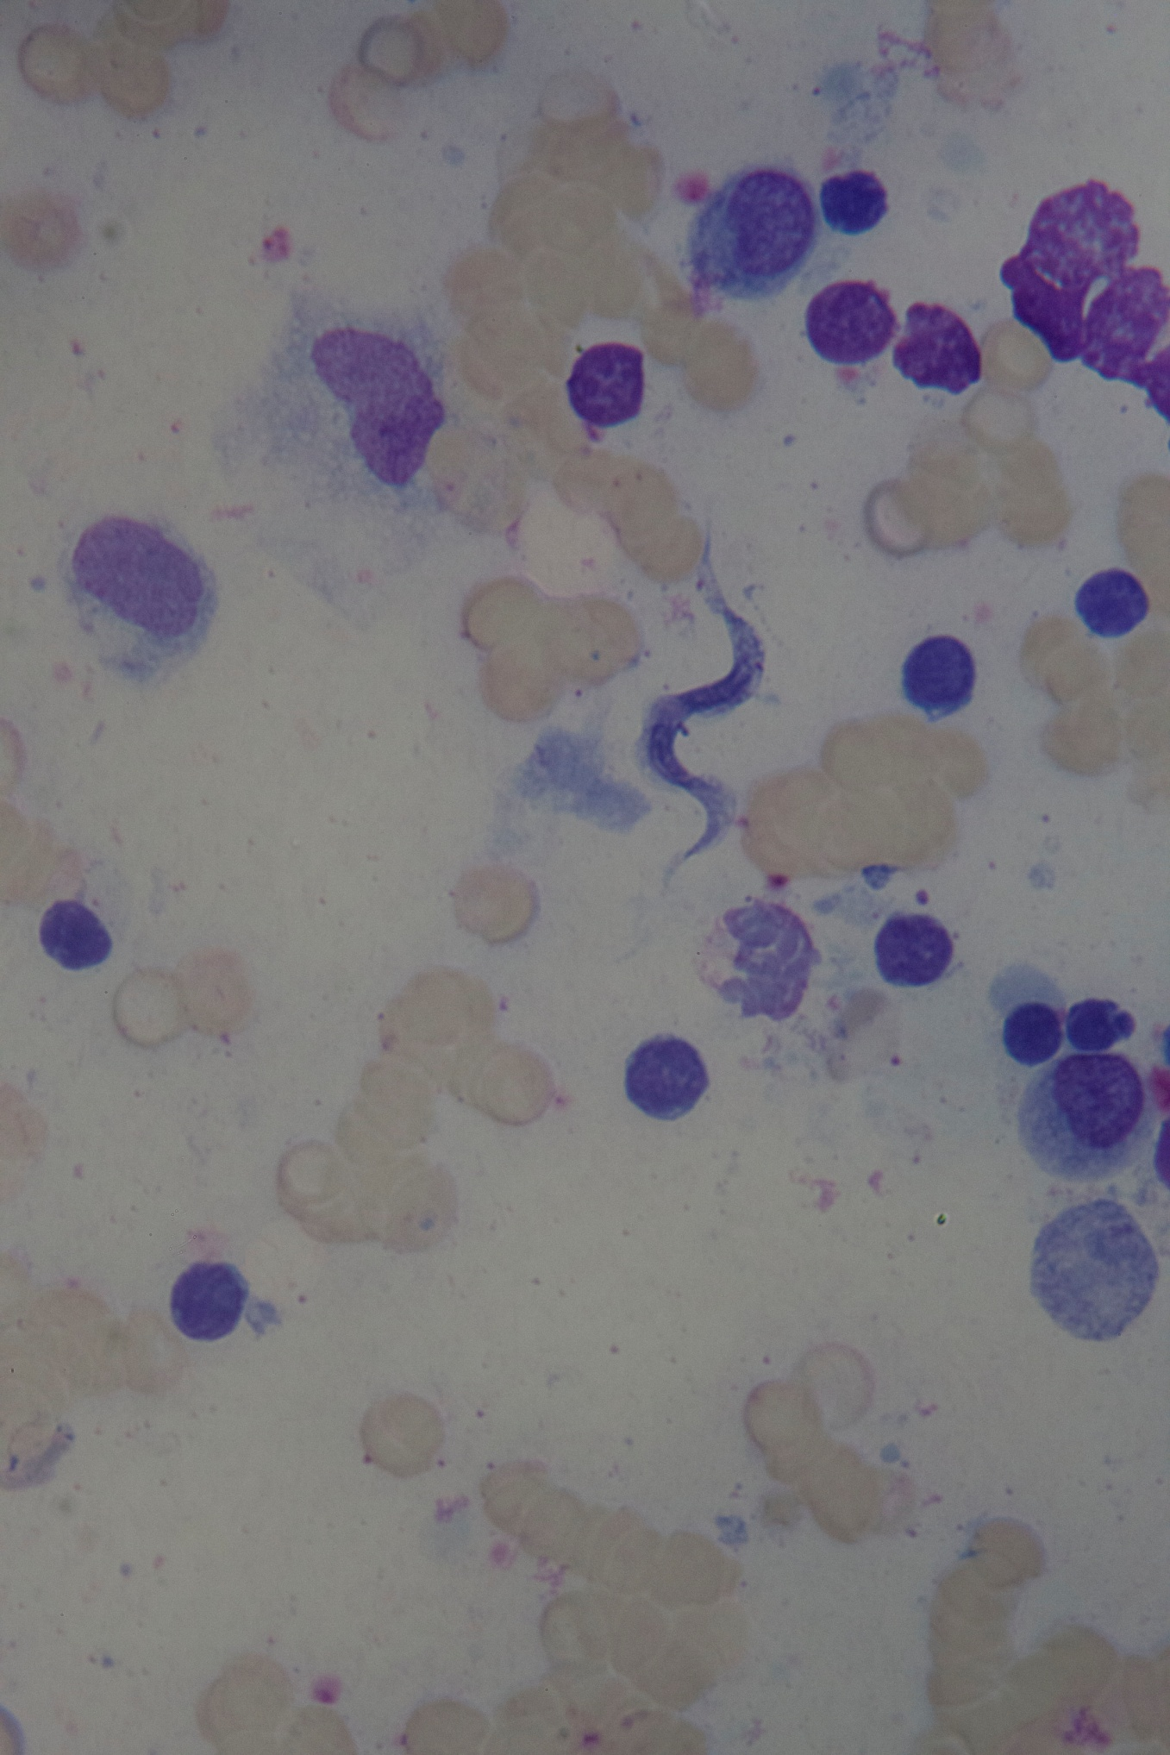

Theileri clade (T. cyclops) trypanosome – KCR 3092, Bunomys chrysocomus
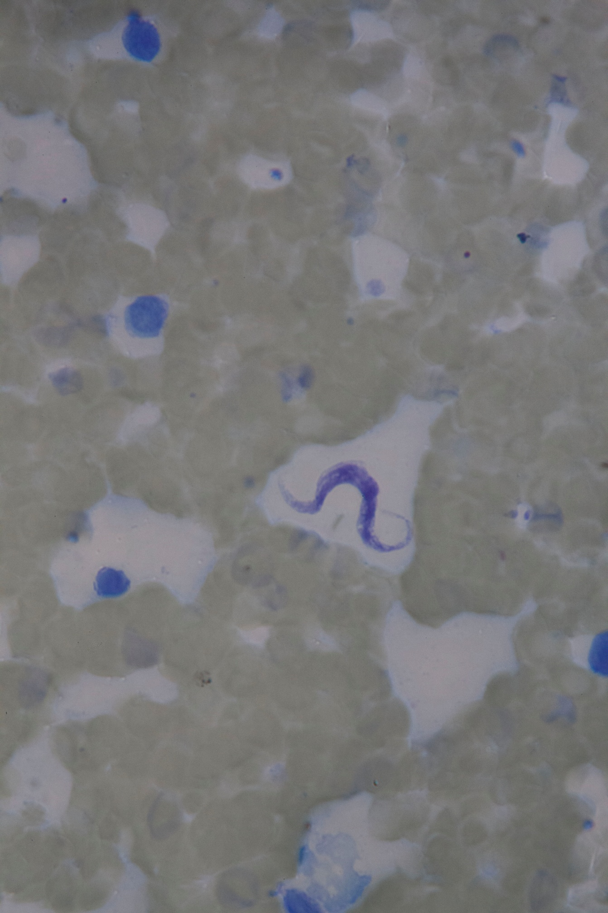

Theileri clade (T. cyclops) trypanosome – KCR 3117, Bunomys chrysocomus
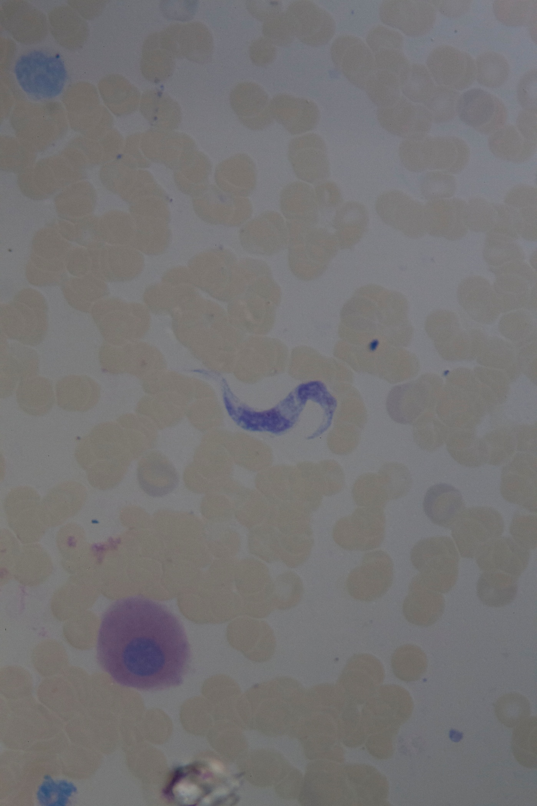

Theileri clade (T. cyclops) trypanosome – KCR 3137, Bunomys chrysocomus
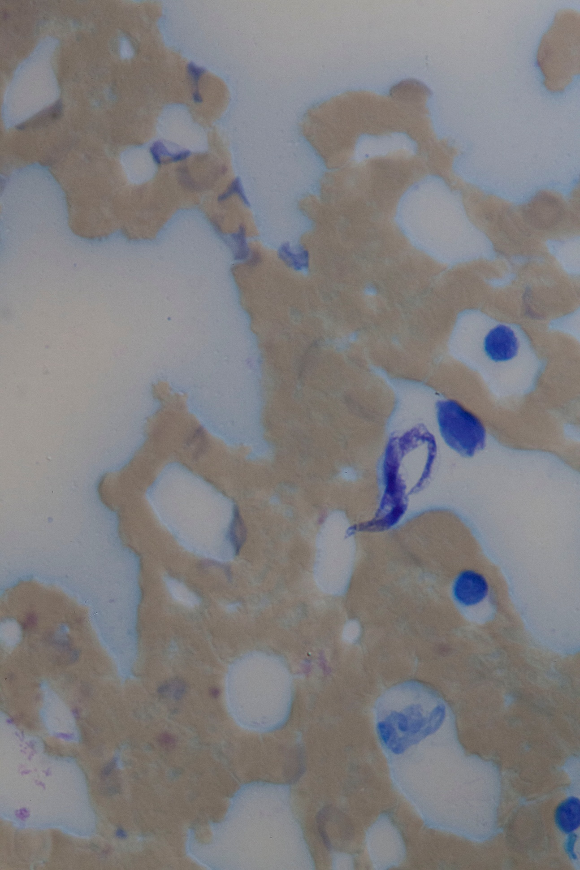

Theileri clade (T. cyclops) trypanosome – KCR 3152, Maxomys musschenbroekii
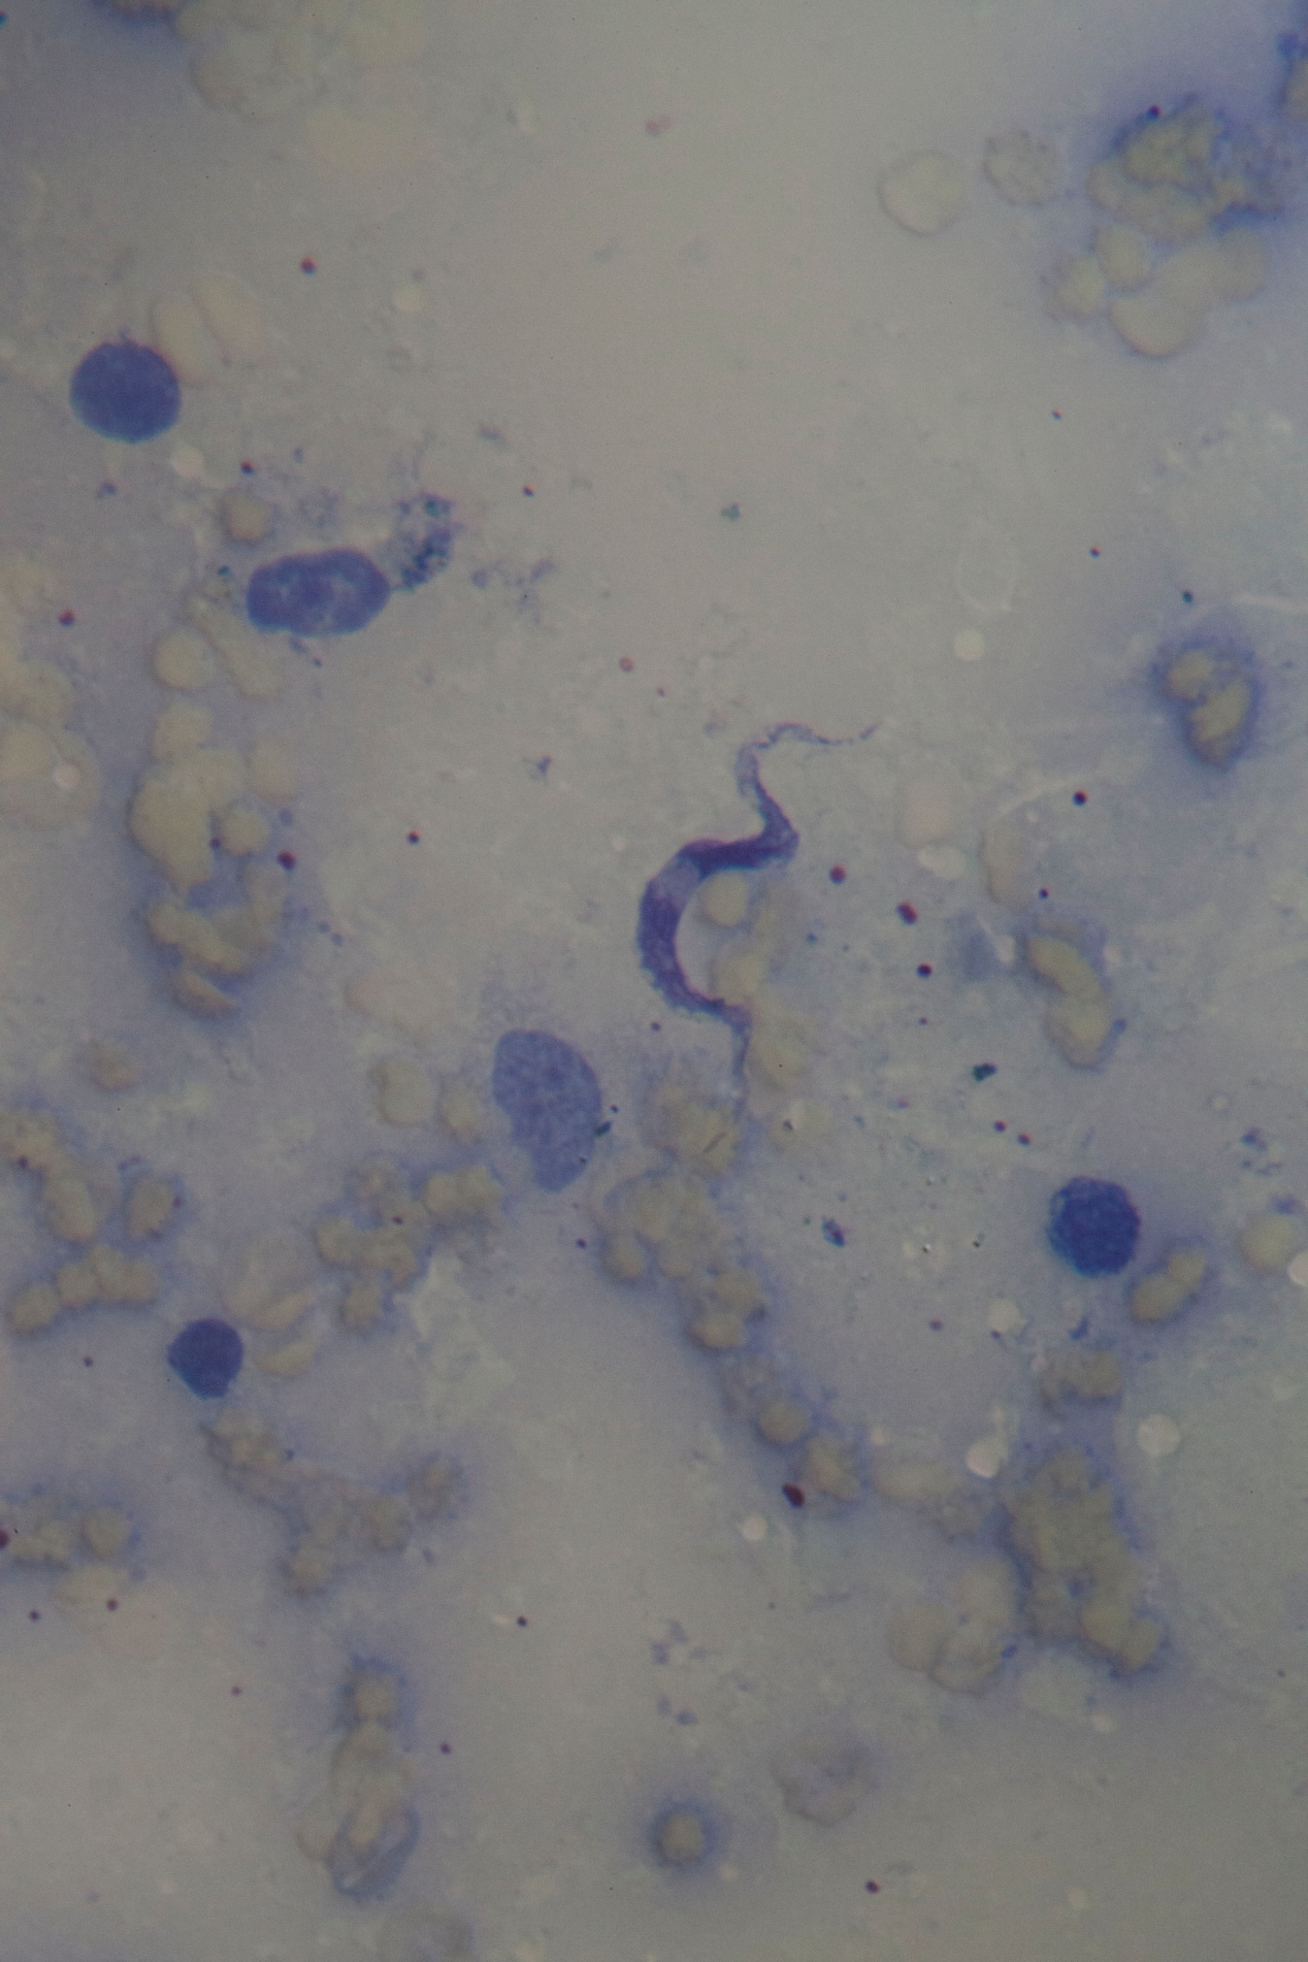

Theileri clade (T. cyclops) trypanosome – KCR 3396, Crocidura ordinaria
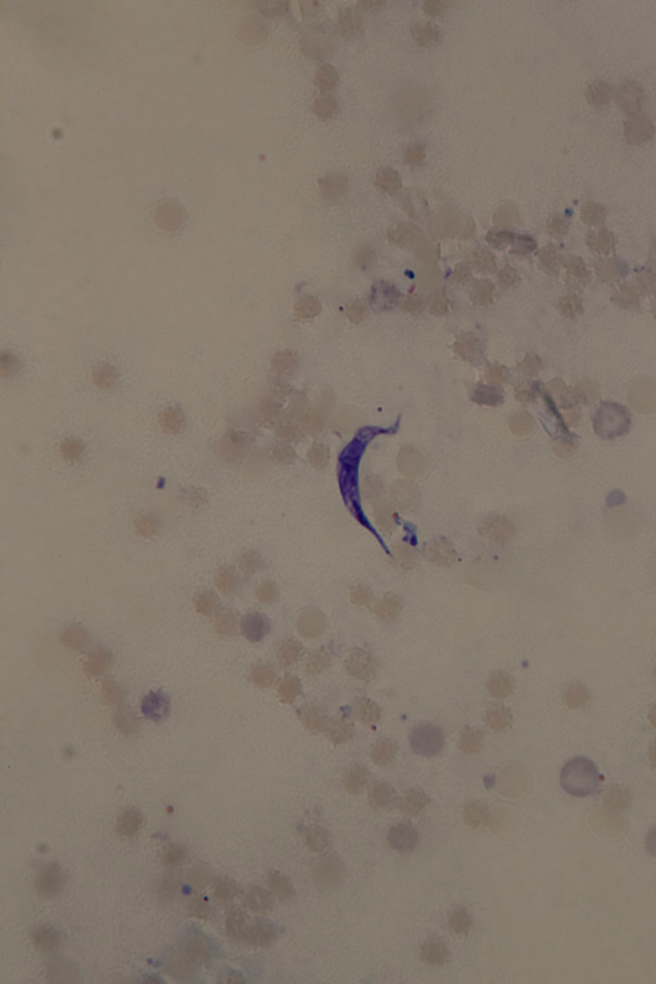

Theileri clade (T. cyclops) trypanosome – KCR 3472, Crocidura elongata
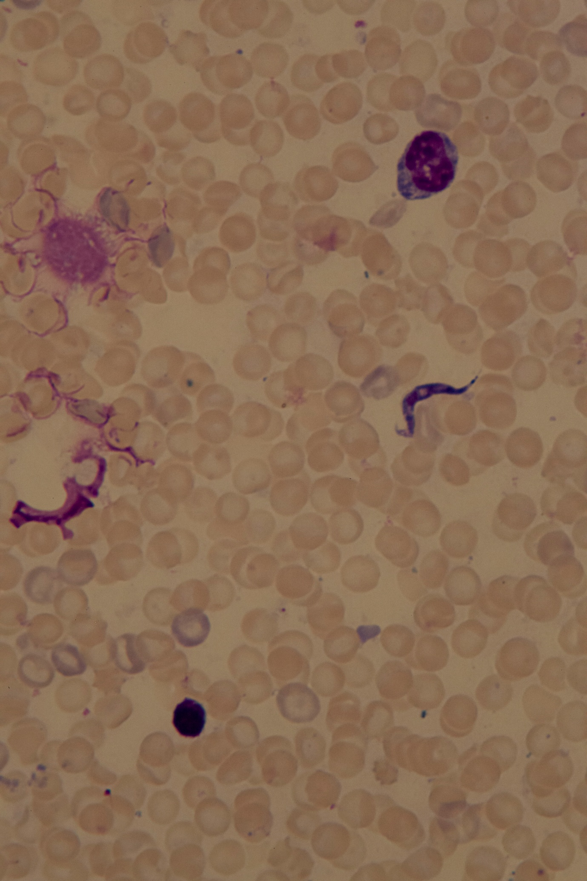

Theileri clade (T. cyclops) trypanosome – KCR 3502, Crocidura lea
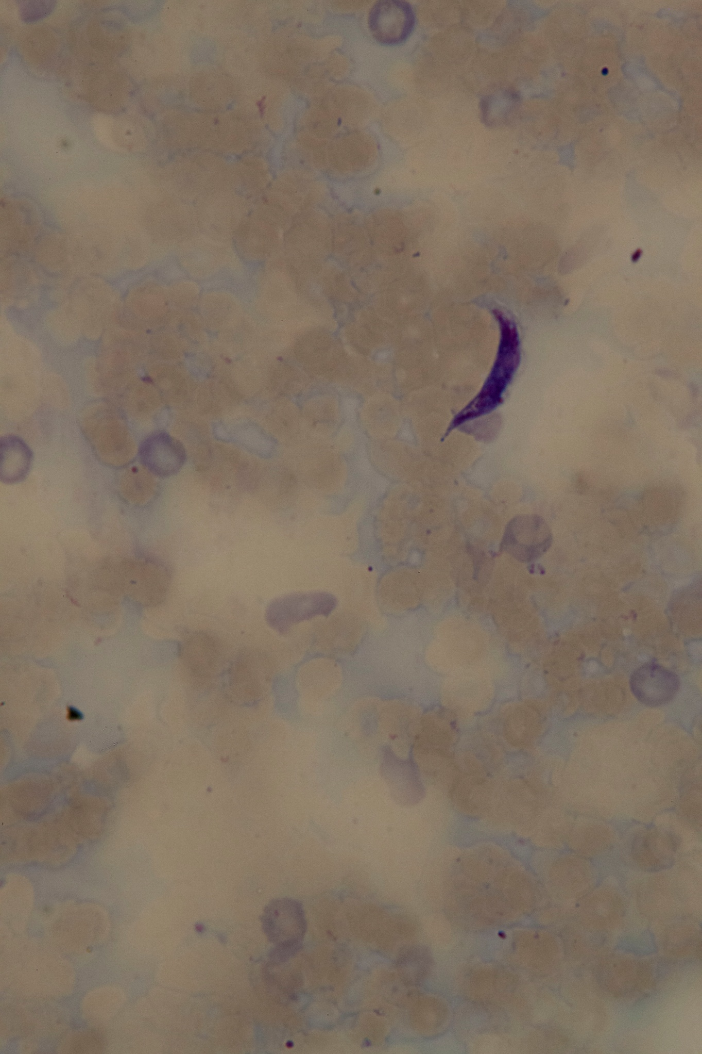

Theileri clade (T. cyclops) trypanosome – KCR 3532, Crocidura lea
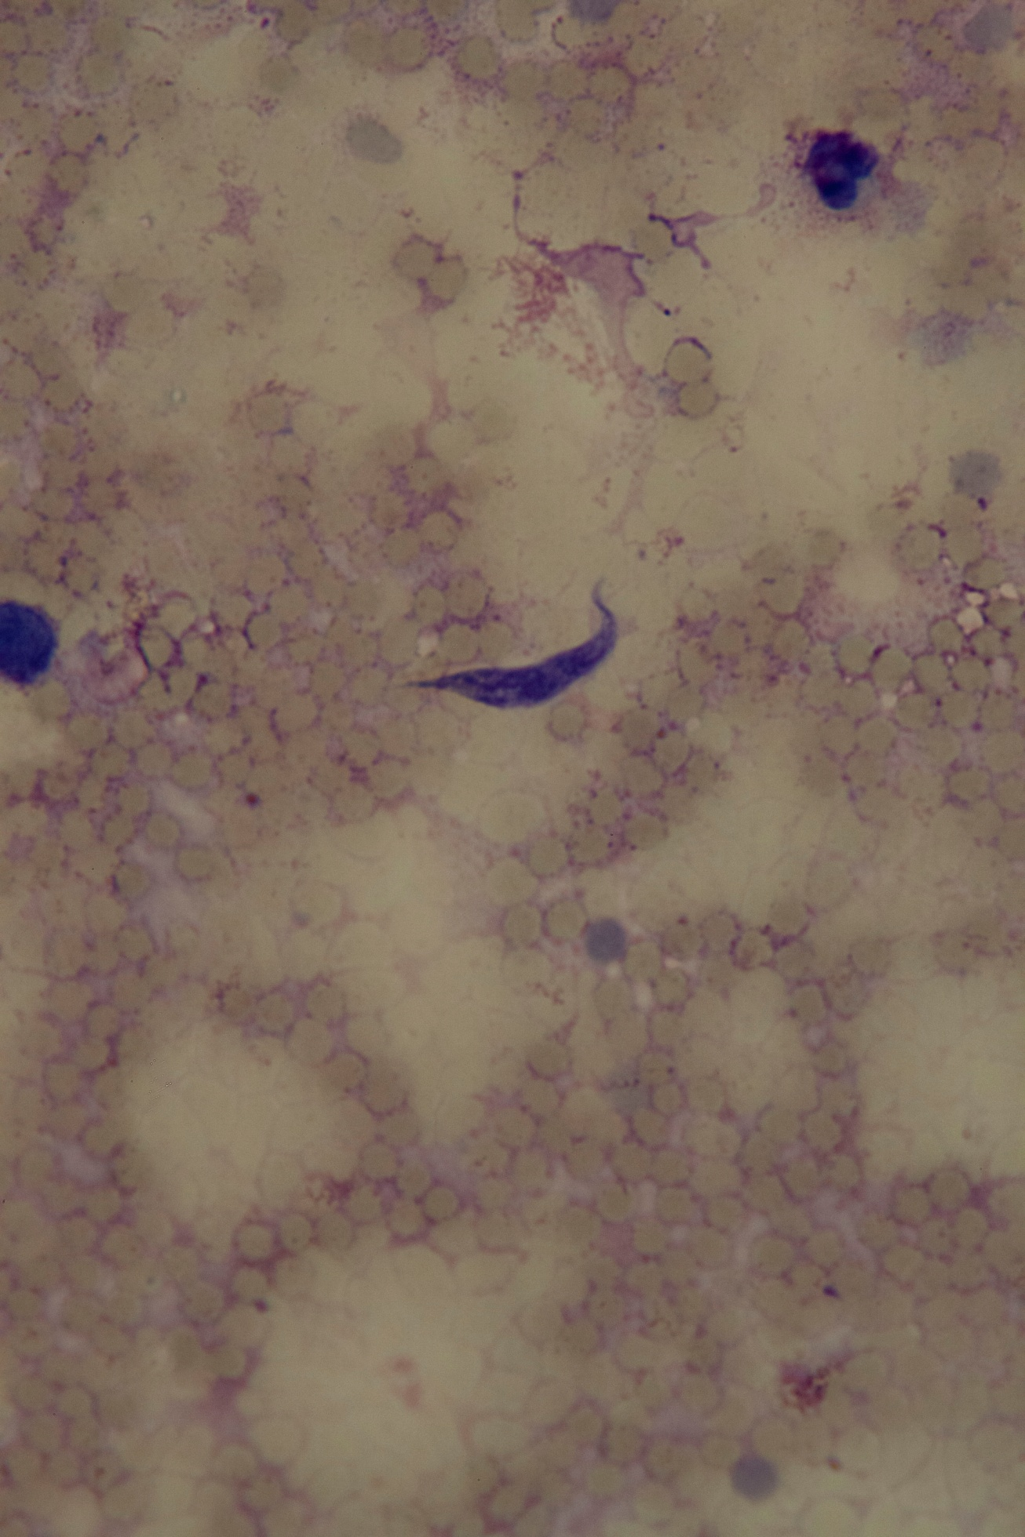

Theileri clade (T. cyclops) trypanosome – KCR 3534, Crocidura nigripes
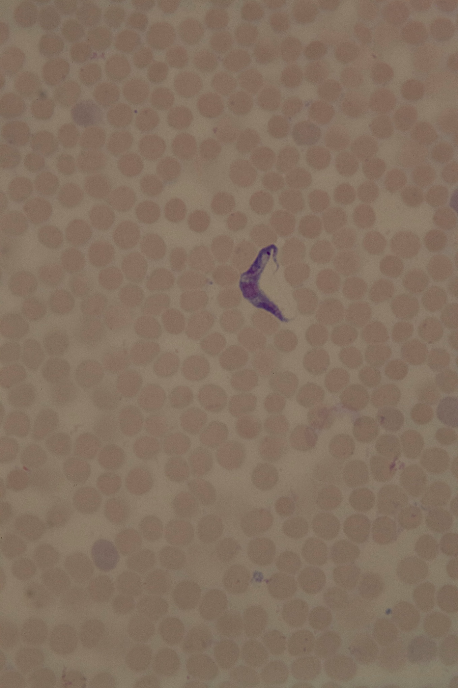

Theileri clade (T. cyclops) trypanosome – KCR 3536, Crocidura lea
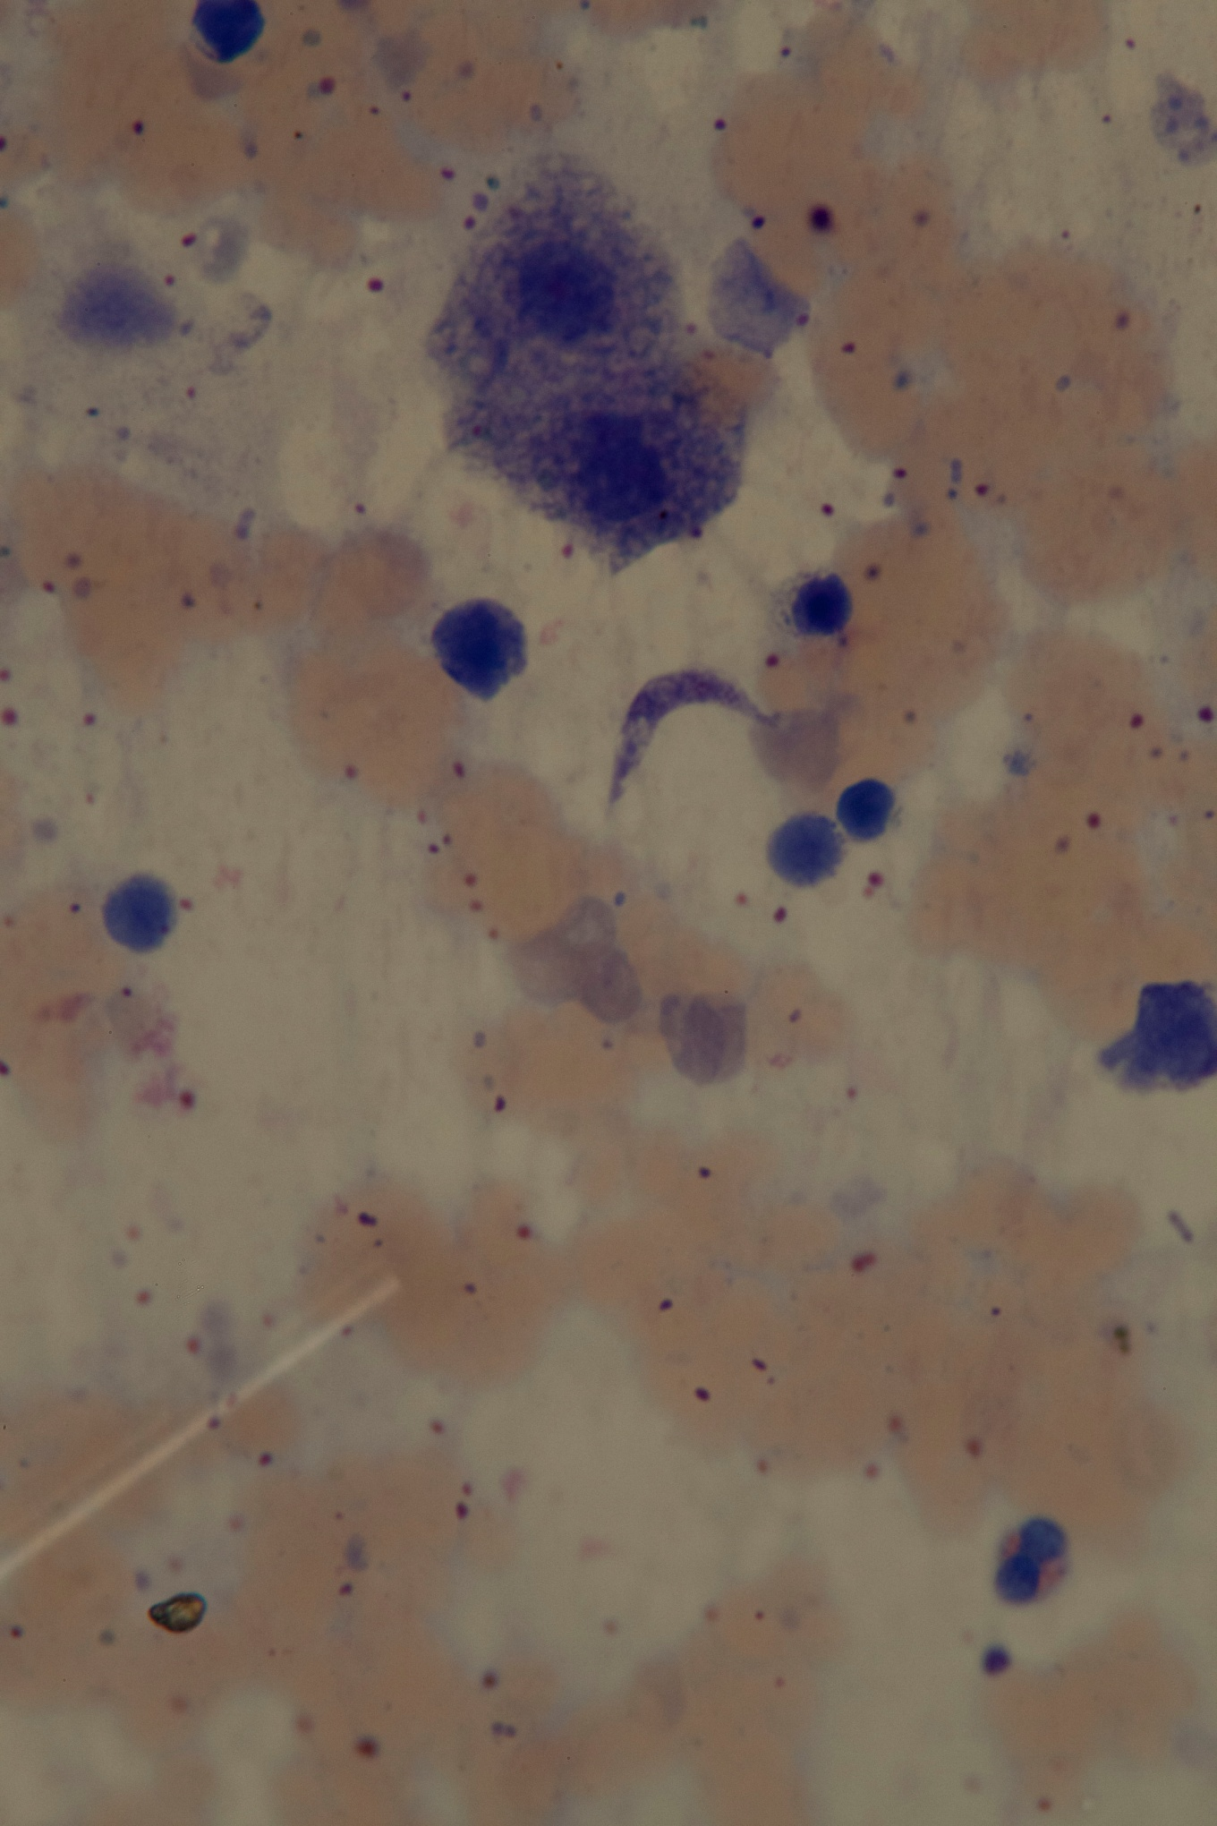
Theileri clade (T. cyclops) trypanosome – KCR 3538, Bunomys chrysocomus
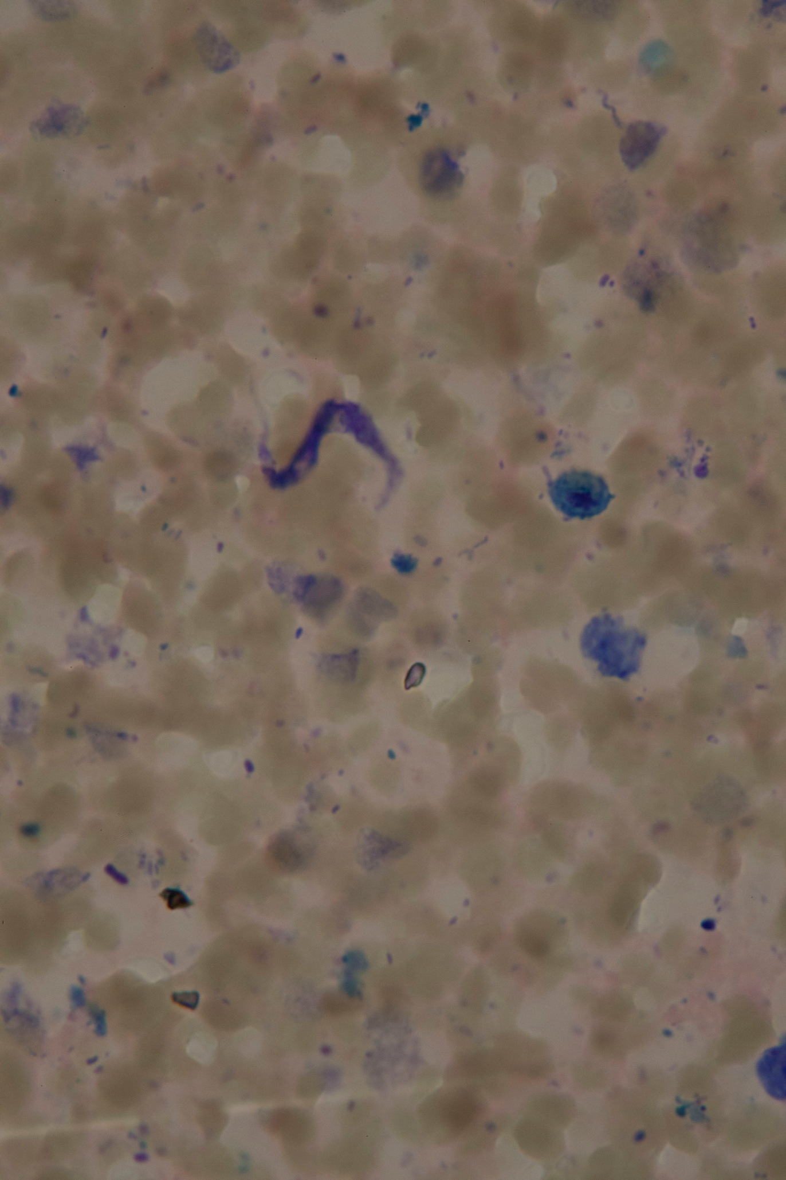

Theileri clade (T. cyclops) trypanosome – KCR 3592, Maxomys musschenbroekii
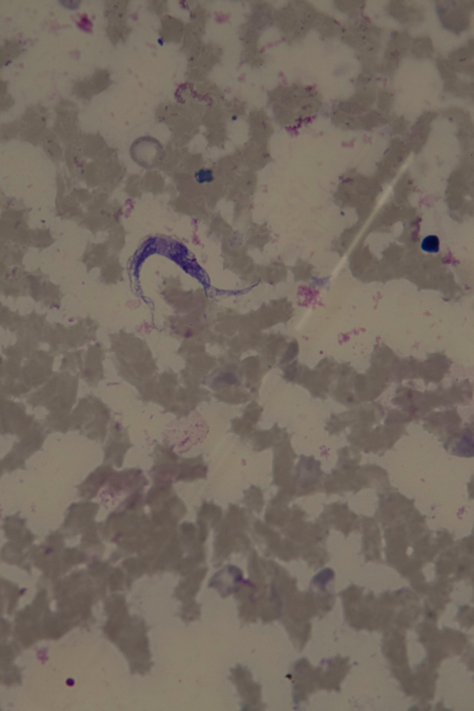

Theileri clade (T. cyclops) trypanosome – KCR 3650, Maxomys musschenbroekii
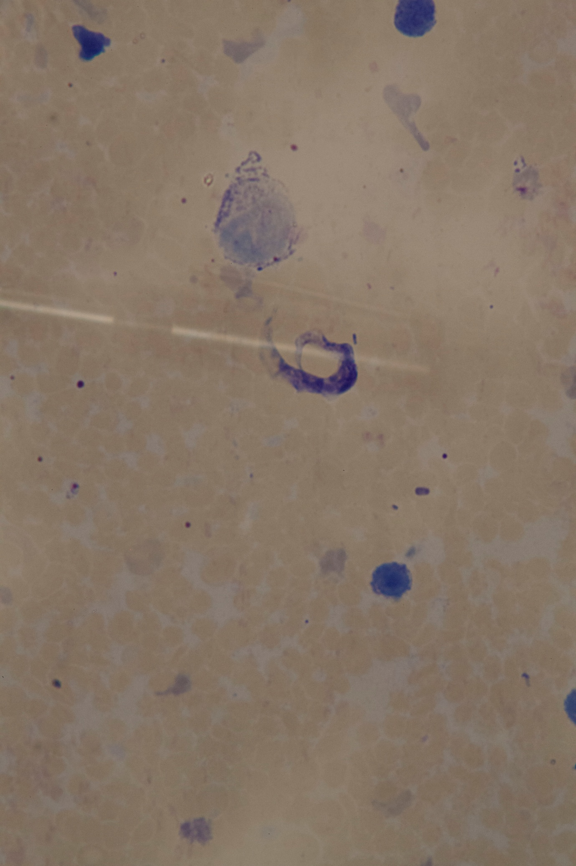

Theileri clade (T. cyclops) trypanosome – KCR 3671, Bunomys chrysocomus
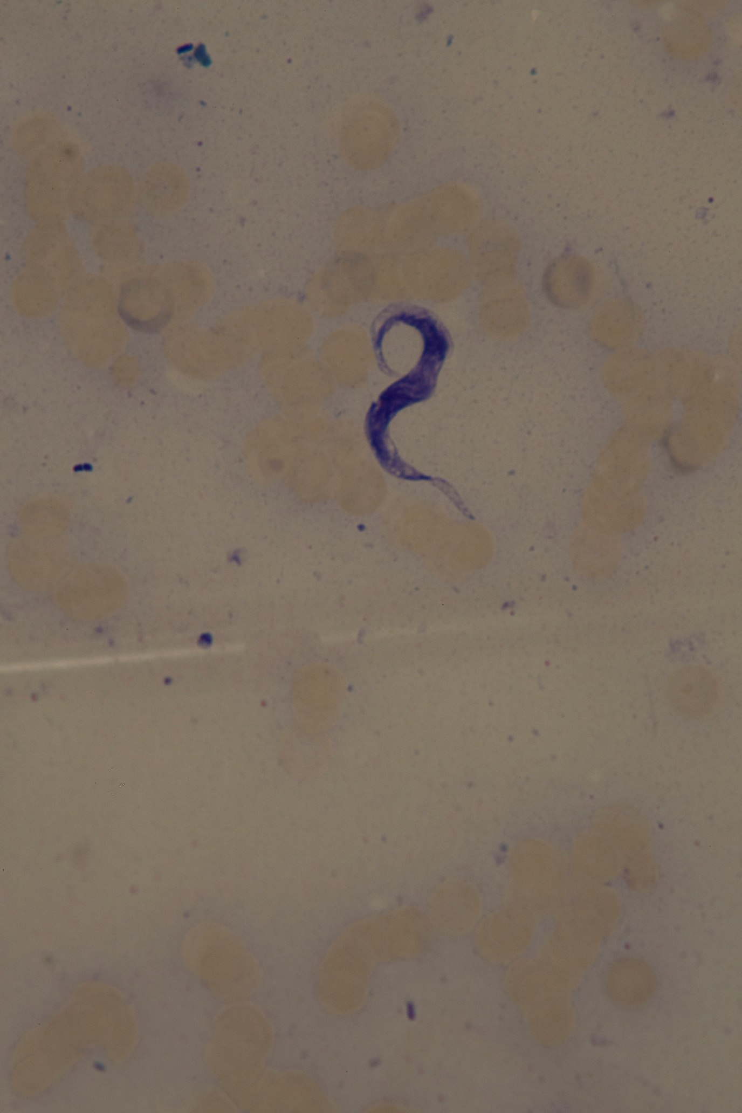

Theileri clade (T. cyclops) trypanosome – KCR 3719, Crocidura pseudorhoditis
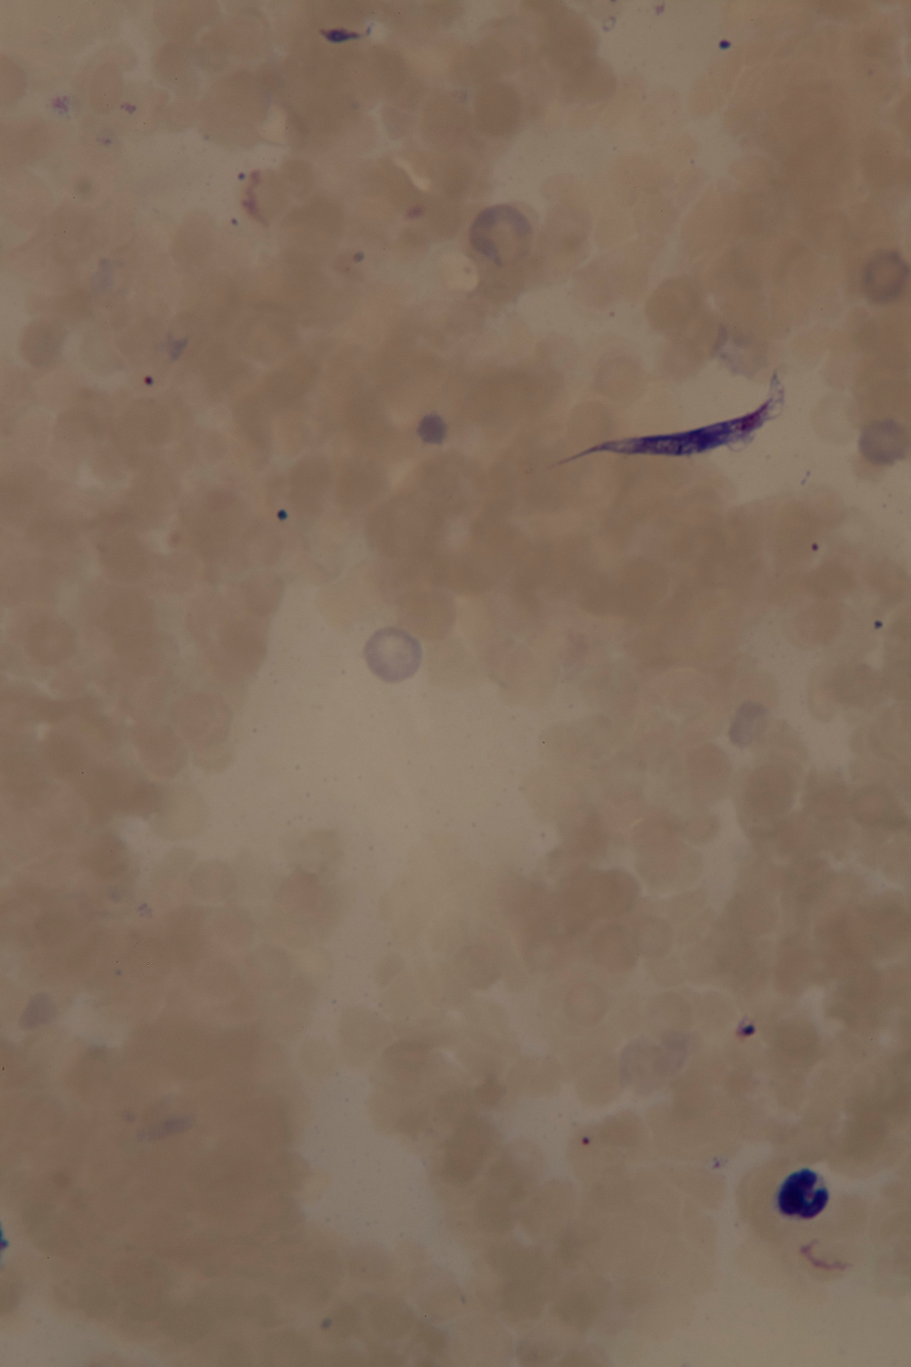

Theileri clade (T. cyclops) trypanosome – KCR 3726, Crocidura elongata
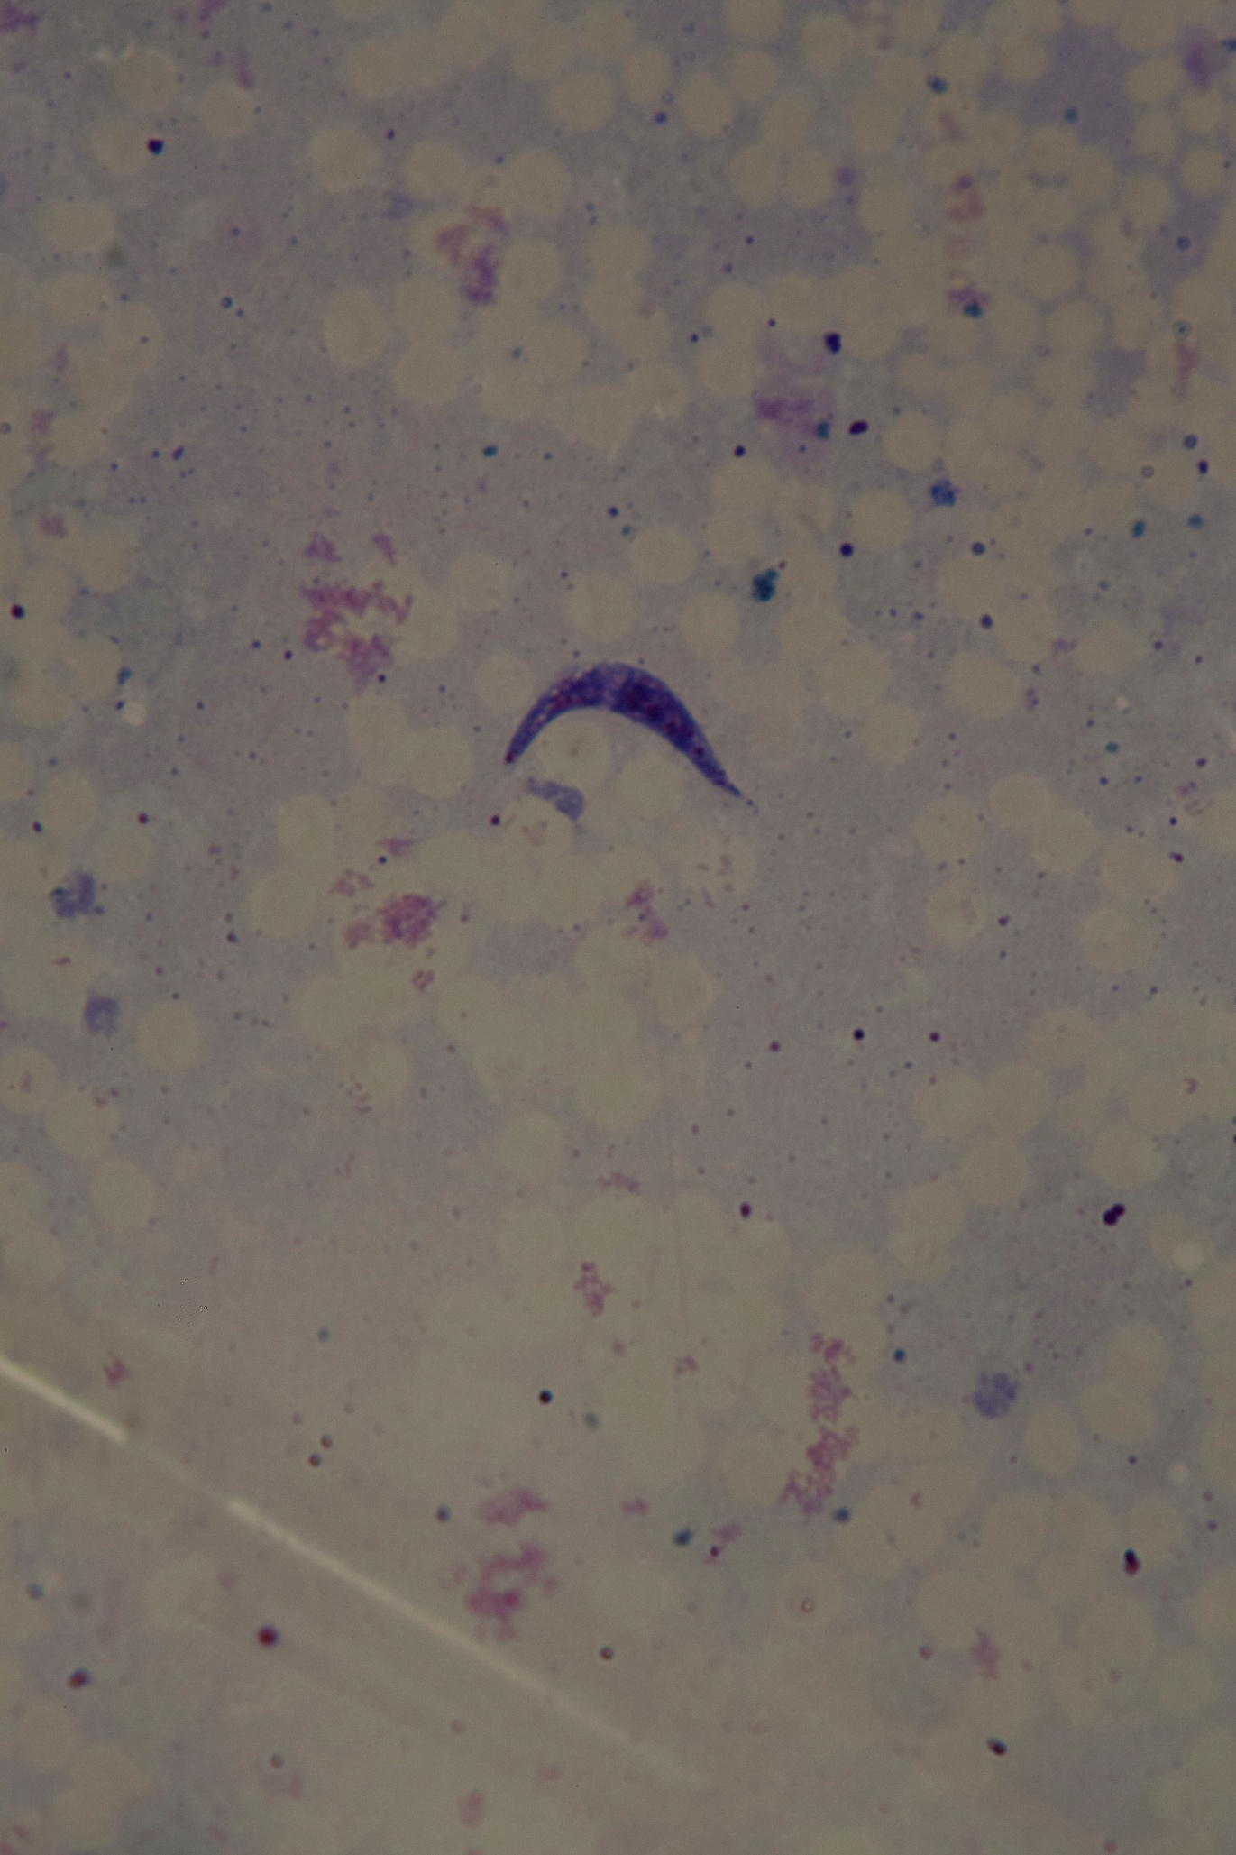

Theileri clade (T. cyclops) trypanosome – KCR 3730, Crocidura elongata
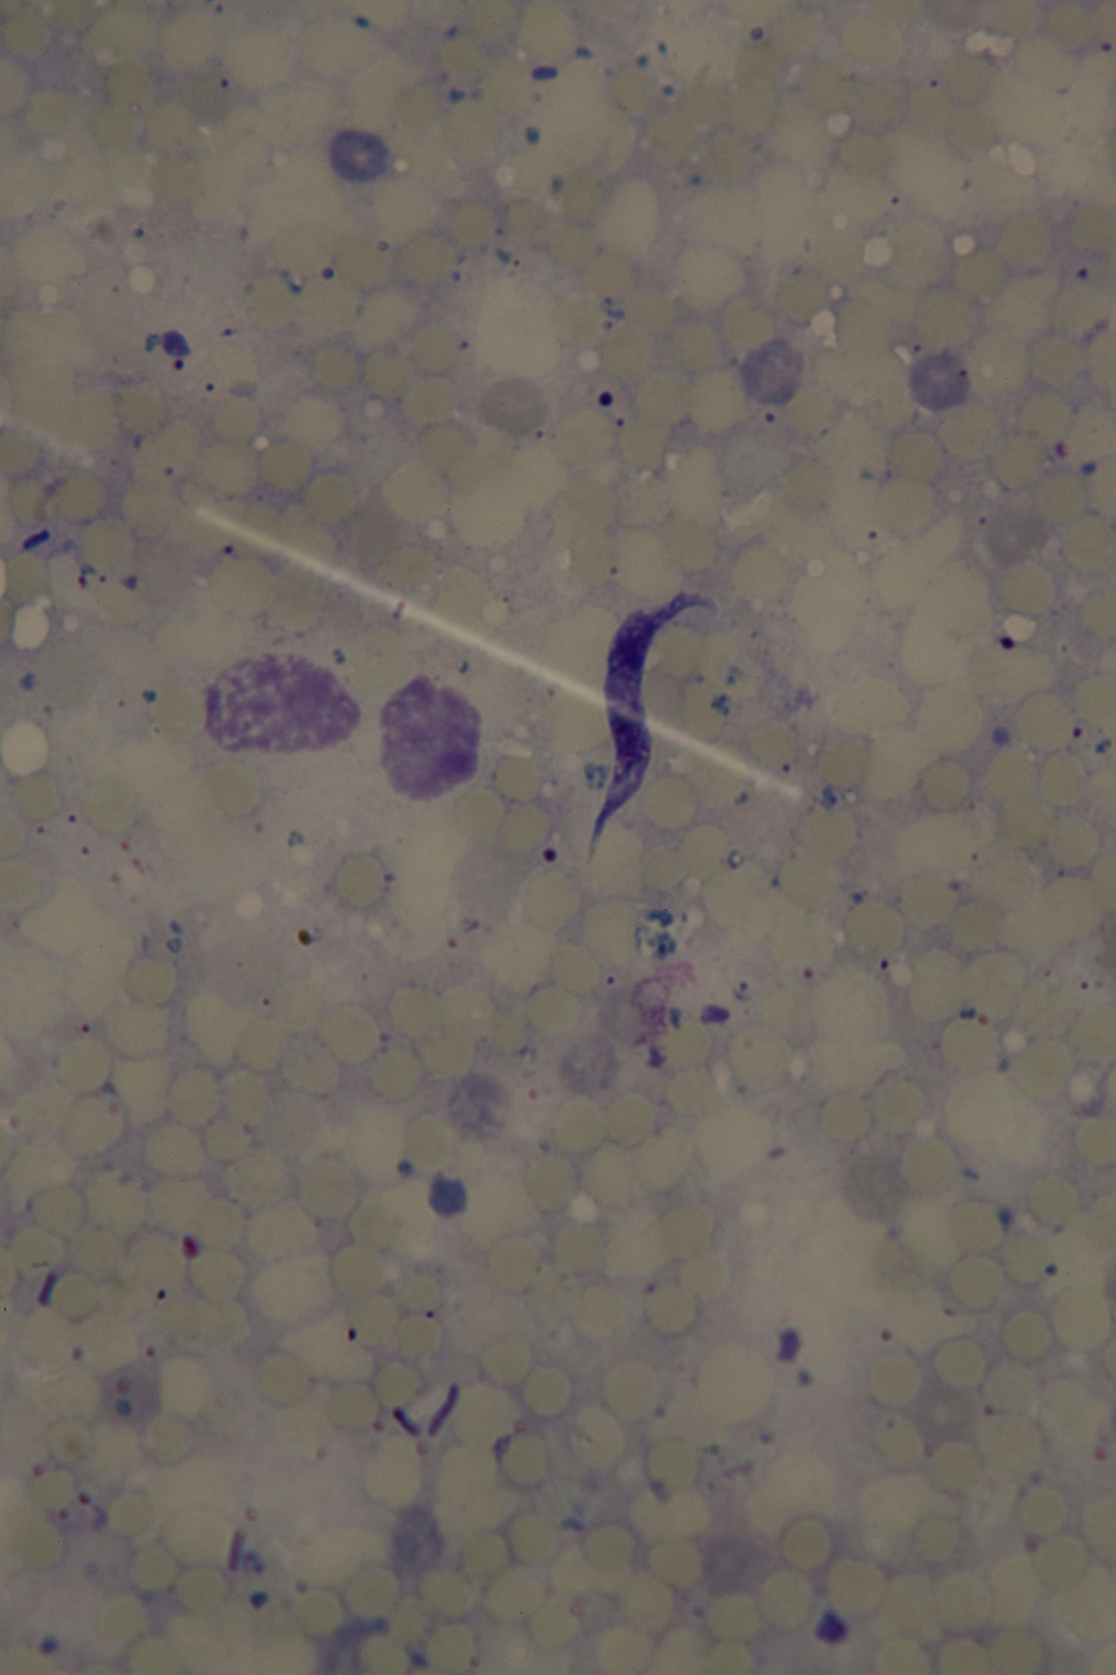

Theileri clade (T. cyclops) trypanosome – KCR 3738, Frateromys fratrorum (x400 magnification)
