Stegner, M. A., and E. A. Hadl. 2025. Influence of late Holocene climate and wildfire on mammalian community composition in the northern Rocky Mountains (USA). Therya. DOI:10.12933/therya-25-6173.

**Supplementary material**

Stegner, M.A., and E.A. Hadly. Influence of late Holocene climate and wildfire on mammalian community composition in the northern Rocky Mountains (USA)

**Supplemental 1: Lithology and Thickness of Stratigraphic Levels from the Deposits of Waterfall Locality**

**Table S1.1**

|  |  |  |  |
| --- | --- | --- | --- |
| Stratigraphic level | Average top depth  below datum (cm)a | Thickness (cm) | Lithology |
| 1 | 26 | 2-20 | Organic |
| 2A | 40 | 2-10 | Organic |
| 2B | 47 | 1-7 | Organic |
| 3 | 50 | 2-10 | Alluvial |
| 4 | 51 | 1-6.5 | Organic |
| 5 | 53 | 4-10 | Dolomite roof fall |
| 6 | 57 | 1-6 | Organic |
| 7 | 59 | 3-8 | Dolomite roof fall |
| 8 | 61 | 3-11 | Organic |
| 9 | 69 | 4-30 | Dolomite w/ organics |
| 9A | 62 |  | Organic |
| 10 | 78 | 2-6 | Organic |
| 11 | 90 | 6-12 | Dolomite roof fall |
| 12 | 93 | 4-12 | Alluvial w/ organics |
| 13 | 98 | 5-20 | Organic |
| 14 | 115 | 4-14 | Alluvial w/ organics; roof fall |
| 15 | 126 | 17-30 | Alluvial |
| 16 | 169 | 19-27 | Dolomite roof fall w/ organics |
| 17 | 188 | 3-8 | Alluvial |
| 18 | 193 | 4-7 | Dolomite roof fall |
| 19 | 199 | 20-36 | Alluvial |

a Depth used to produce age-vs-depth models.

**Supplemental 2: Number of Identified Specimens (NISP) counts for all excavation units.**

Units that were roof fall or flood deposit (indicated by *), or undifferentiated were not included in the statistical analyses.

**Table S2.1**

|  |  |  |  |  |  |  |  |  |  |  |  |  |  |  |  |  |  |  |  |  |
| --- | --- | --- | --- | --- | --- | --- | --- | --- | --- | --- | --- | --- | --- | --- | --- | --- | --- | --- | --- | --- |
| **Unit** | **1** | **2** | **3\*** | **4** | **5\*** | **6** | **8** | **9** | **9A** | **10** | **11\*** | **12** | **13** | **14** | **15** | **16** | **17\*** | **Undiff** | **Undiff 1-3** | **Undiff +14** |
| *Sorex* (*Otisorex*) sp. |  |  | 7 | 4 |  |  |  | 5 |  |  |  |  |  |  |  | 32 |  | 4 | 4 |  |
| *Sorex* (*Sorex*) sp. |  |  |  |  |  |  |  |  |  |  |  |  |  |  |  |  |  |  | 6 | 6 |
| *Sorex* spp. |  | 4 |  | 1 |  | 3 |  | 38 | 5 |  | 4 |  | 7 | 14 | 2 |  |  | 30 | 15 | 3 |
| *Puma concolor* |  | 1 |  |  |  |  |  |  |  |  |  |  |  |  |  |  |  |  |  |  |
| *Lynx* sp. |  |  |  |  |  |  |  |  |  |  |  |  |  |  |  |  |  | 2 |  |  |
| *Mustela erminea* |  |  |  |  |  | 4 |  |  |  |  |  |  |  |  |  |  |  |  |  |  |
| *Mustela frenata* |  | 1 |  |  |  |  |  |  |  |  |  |  | 7 |  |  |  |  |  |  |  |
| *Neovison vison* |  |  |  |  |  |  |  | 1 |  |  |  |  |  |  |  |  |  |  |  |  |
| Artiodactyla |  |  |  |  |  | 1 |  |  |  |  |  |  |  |  |  |  |  |  |  |  |
| Cervidae |  |  |  |  |  |  |  |  |  |  |  |  |  |  |  |  |  |  | 1 |  |
| *Cervus elaphus* | 1 |  |  |  |  | 1 |  |  |  |  |  |  |  |  |  |  |  |  |  |  |
| *Odocoileus hemionus* | 1 | 1 |  |  |  |  |  | 1 |  |  |  |  | 1 |  |  |  |  | 1 |  |  |
| *Bison bison* |  |  |  |  |  |  |  |  |  |  |  |  |  |  |  |  |  |  | 1 |  |
| *Ovis canadensis* |  | 3 |  |  |  |  |  |  |  |  |  |  | 1 |  |  |  |  |  |  |  |
| *Marmota flaviventris* | 2 | 6 | 1 | 9 |  |  | 4 | 1 |  |  |  |  | 4 |  |  |  |  | 2 | 4 |  |
| *Urocitellus armatus* | 21 | 40 | 1 | 15 | 1 | 20 | 19 | 68 |  | 6 | 6 |  | 130 | 8 | 2 | 9 |  | 103 | 27 | 10 |
| *Callospermophilus lateralis* | 10 | 1 | 1 |  | 3 | 1 | 20 | 5 |  | 1 |  |  | 23 | 1 | 2 |  |  | 8 | 7 | 3 |
| *Tamias* spp. | 1 | 5 |  | 4 |  | 13 | 1 | 15 | 1 | 1 |  |  | 6 |  | 5 | 6 |  | 16 | 1 |  |
| *Tamiasciurus hudsonicus* | 2 | 5 | 2 |  |  | 1 |  | 10 | 1 | 5 | 2 |  | 18 | 1 |  |  |  | 9 | 3 | 5 |
| *Glaucomys sabrinus* |  | 3 |  |  |  | 1 | 1 | 10 |  |  | 1 | 2 | 3 | 2 |  | 1 | 1 | 3 | 5 |  |
| Sciuridae | 2 | 6 |  | 1 |  | 4 | 2 | 13 | 1 | 1 | 1 |  | 7 |  |  |  |  | 5 | 2 | 4 |
| *Thomomys talpoides* | 2 | 16 |  | 6 |  | 5 | 28 | 54 | 1 |  |  | 2 | 36 | 9 | 20 | 10 |  | 42 | 17 | 3 |
| *Zapus princeps* | 5 | 12 |  |  |  |  | 1 |  |  |  |  |  | 4 |  | 1 |  |  | 2 | 1 |  |
| *Myodes gapperi* | 8 | 3 |  | 1 |  | 11 | 3 | 33 |  |  |  | 7 | 63 | 16 | 26 | 33 | 6 | 37 | 5 | 9 |
| *Microtus pennsylvanicus* |  | 2 |  |  |  |  |  | 1 |  |  |  |  |  |  |  |  |  | 1 |  |  |
| *Microtus richardsoni* |  | 1 | 1 |  |  | 3 |  |  |  |  |  |  | 2 |  |  |  |  | 1 |  |  |
| *Microtus* spp. | 26 | 72 |  | 11 |  | 26 | 9 | 73 | 1 | 15 | 4 | 1 | 45 | 14 | 11 | 13 | 7 | 72 | 21 | 24 |
| *Phenacomys intermedius* | 6 | 18 | 4 | 3 | 1 | 7 | 5 | 67 |  | 3 | 2 | 4 | 20 | 9 | 12 | 8 | 1 | 23 | 14 | 9 |
| *Neotoma cinerea* | 14 | 64 | 2 | 13 | 1 | 16 | 19 | 65 | 4 |  |  | 1 | 22 | 13 | 25 | 6 | 4 | 39 | 20 | 23 |
| *Peromyscus* cf. *maniculatus* | 6 | 12 | 3 | 3 |  | 12 | 2 | 64 | 1 | 3 |  | 2 | 14 | 7 | 5 | 6 |  | 25 | 21 | 5 |
| *Erethizon dorsatum* |  |  |  |  |  |  |  |  | 5 |  |  |  |  |  |  |  |  |  |  |  |
| Lagomorpha |  |  |  |  |  | 1 |  | 4 |  |  |  | 1 | 6 |  |  |  |  | 3 | 1 | 1 |
| *Ochotona princeps* | 5 | 2 |  |  |  |  |  |  | 1 |  |  |  |  |  |  |  |  |  |  |  |
| Leporidae | 3 | 46 | 4 | 5 | 2 | 3 | 5 | 69 | 4 | 2 | 2 | 5 | 52 | 14 | 14 | 1 |  | 62 | 8 | 10 |
| *Lepus* cf. *americanus* | 1 | 1 | 1 |  |  |  | 1 | 4 |  |  |  |  | 16 | 1 | 1 | 2 |  | 17 |  | 1 |
| *Lepus* spp. |  | 3 |  | 3 |  |  |  |  |  |  |  |  | 1 |  | 1 | 6 |  | 1 | 5 |  |
| *Sylvilagus* cf. *nuttallii* |  | 2 |  |  |  |  |  | 5 | 1 |  |  |  | 1 |  |  |  |  |  |  | 1 |

**Supplemental 3: Comparison of bone, charcoal, and combined Bayesian age models.**

**Figure S3.1 Comparison of bone, charcoal, and combined Bayesian age models.** Solid lines show the 50% confidence interval of the age model; shaded polygons show the 95% confidence interval. Filled circles are the mean age of each radiocarbon sample. Red – age model constructed from charcoal dates; Gray - age model constructed from bone dates; Blue = age model constructed from both charcoal and bone dates. All models include the top of the deposit as the year of excavation, 1991 C.E.

**Supplemental 4. Habitat affiliations and diel activity of Waterfall Locality taxa.**

**Table S5.1** *Open/Closed affiliation:* “Closed” indicates taxa which prefer closed environments, i.e., forests. “Open” indicates taxa which prefer open environments, i.e., grasslands and riparian zones. “Both” indicates taxa which either had no preference for open versus closed environments, or where, for subgenus, genus, family, and order-level designations, both closed and open environment species are found within the Yellowstone region. *Diel Activity*: Diel activity was ranked as 1-strictly diurnal, 2-mostly diurnal, 3-no preference, 4-mostly nocturnal, 5-strictly nocturnal, or 999-taxonomic level was too broad to assign diel activity.

|  |  |  |  |
| --- | --- | --- | --- |
| **Taxon** | **Open/Closed**  **Affiliationa** | **Diel Activityb** | **Notes** |
| *Sorex* (Otisorex) sp. | Both | 4 |  |
| *Sorex* (Sorex) sp. | Both | 4 |  |
| *Sorex* sp. | Both | 4 |  |
| *Puma concolor* | Closed | 4 |  |
| *Lynx* sp. | Closed | 4 |  |
| *Mustela erminea* | Both | 3 |  |
| *Mustela frenata* | Open | 3 |  |
| *Neovison vison* | Both | 4 |  |
| Artiodactyla | Both | 999 |  |
| Cervidae | Both | 4 | Ranked as mostly nocturnal by assessing all native Cervidae in North America. *Rangifer tarrandus* is mainly diurnal, but is not found in Yellowstone National Park |
| *Cervus elaphus* | Both | 4 |  |
| *Odocoileus hemionus* | Both | 4 |  |
| *Bison bison* | Open | 1 |  |
| *Ovis canadensis* | Open | 1 |  |
| *Marmota flaviventris* | Open | 1 |  |
| *Urocitellus armatus* | Open | 1 |  |
| *Callospermophilus lateralis* | Closed | 1 |  |
| *Tamias* sp. | Both | 1 |  |
| *Tamiasciurus hudsonicus* | Closed | 1 |  |
| *Glaucomys sabrinus* | Closed | 5 |  |
| Sciuridae | Both | 999 |  |
| *Thomomys talpoides* | Both | 3 |  |
| *Zapus princeps* | Both | 4 |  |
| *Myodes gapperi* | Closed | 3 |  |
| *Microtus pennsylvanicus* | Both | 3 |  |
| *Microtus richardsoni* | Both | 4 |  |
| *Microtus* sp. | Both | 4 |  |
| *Phenacomys intermedius* | Both | 4 |  |
| *Neotoma cinerea* | Both | 4 |  |
| *Peromyscus* cf. *maniculatus* | Both | 5 |  |
| *Erethizon dorsatum* | Closed | 4 |  |
| Lagomorpha | Both | 999 |  |
| *Ochotona princeps* | Both | 1 |  |
| Leporidae | Both | 4 |  |
| *Lepus* cf. *americanus* | Closed | 4 |  |
| *Lepus* sp. | Both | 4 |  |
| *Sylvilagus* cf. *nuttallii* | Both | 3 | Crepuscular; ranked as no preference under the assumption that nocturnal/diurnal predators would have equal chances of capturing this species |

a Foresman (2001), Streubel (1995)

b Reid (2006)

**References**

Foresman, K. R. (2001). The wild mammals of Montana. Lawrence, Kansas, Allen Press, Inc.

Streubel, D. (1995) Small mammals of the Yellowstone ecosystem. Boulder, Colorado, Robert Rinehart, Inc. Publishers.

Reid, F.A. 2006. Peterson guide to mammals of North America. 4th edition. Houghton Mifflin Company, New York.

**Supplemental 5. Relationships between climate and small mammal diversity and community composition.**

To account for the age range of each excavation unit, we resampled the ages for each level from the Bayesian age model posteriors. We matched each of the 1000 age estimations for each level to the closest age in the climate time series to calculate a range of possible climate values for each level (Figure S5.1). To correlate each climate variable to each of the biodiversity measures, we sampled the distribution of possible climate values for each level, calculated the Pearson’s product moment correlation between the biodiversity metric and climate through time, then iterated 1000 times. This generated a distribution of observed Pearson’s test statistics (Figures S5.2-S5.8). We compared this to a distribution of null Pearson’s test statistics generated by permutation. We used student’s T tests to determine if the distributions of observed and null test statistic distributions were significantly different from one another.

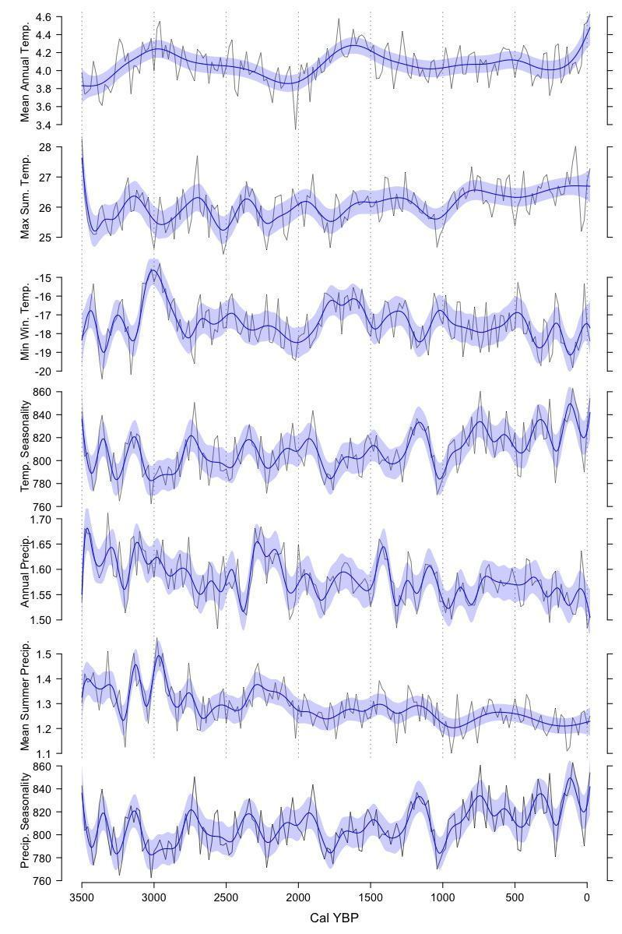

**Figure S5.1 Climate changes at Waterfall Locality since 3,500 cal YBP.** Data are modeled climate times series data averaged over 30-year intervals with 20-year interval steps from PaleoView (Fordham et al. 2017), for latitude: 42.5-45° N, longitude 112.5-110° W, which includes Waterfall Locality. To visualize long-term trends, blue shaded areas show GAM models fitted with adaptive basis splines using the *mgcv* package (Wood, 2011) in R (R Core Team, 2022). Model fits were checked using the *mgcv* ‘gam.check’ function to ensure that residuals were normally distributed and had no trend through time.

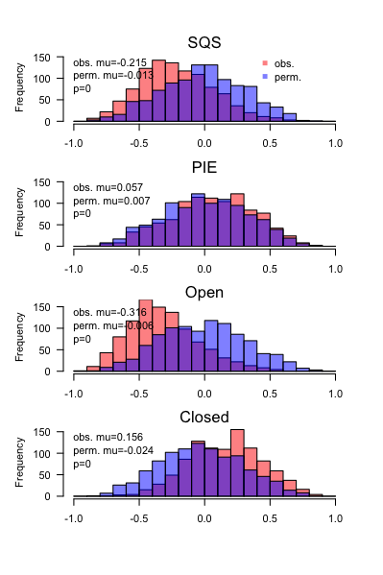

**Figure S5.2 Pearson’s test correlation coefficients for Annual precipitation.** Distribution of observed (red shading) and permuted (blue shading) Pearson’s product moment test statistics, with observed mean (obs. mu) and permuted mean (perm. mu) values and student’s T-test p values.

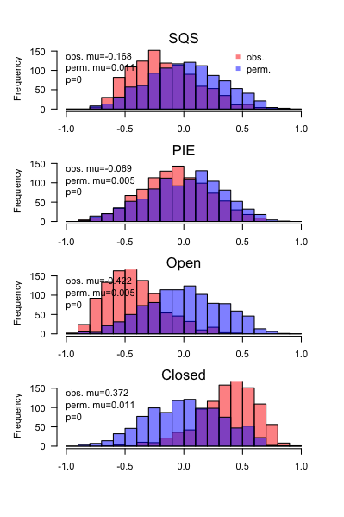

**Figure S5.3 Mean summer precipitation.** Style follows figure S5.2.

**Figure S5.4 Precipitation seasonality.** Style follows figure S5.2.

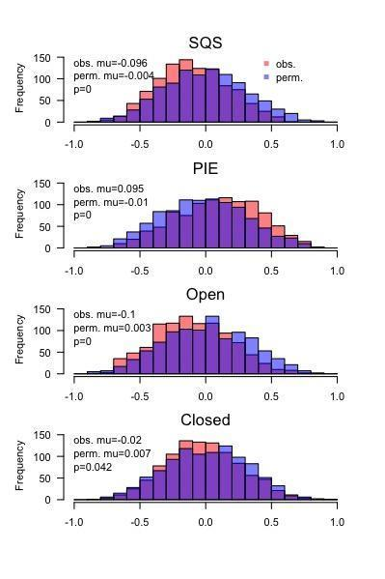

**Figure S5.5 Mean Annual Temperature.** Style follows figure S5.2.

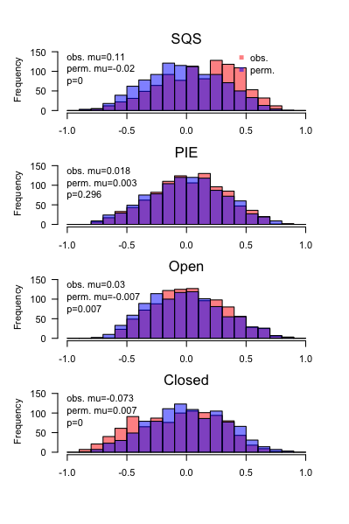

**Figure S5.6 Maximum Summer Temperature.** Style follows figure S5.2.

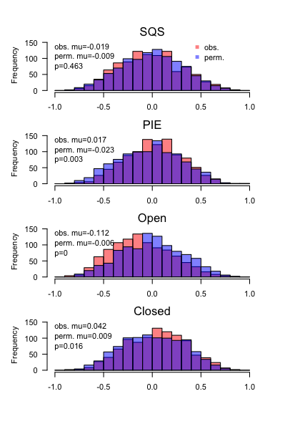

**Figure S5.7 Minimum Winter Temperature.** Style follows figure S5.2.

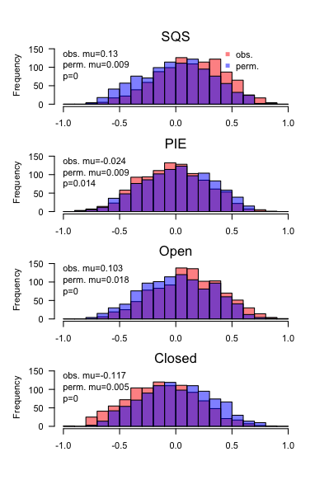

**Figure S5.8 Temperature seasonality.** Style follows figure S5.2.

**References**

Fordham, D.A., Saltré, F., Haythorne, S., Wigley, T.M.L., Otto-Bliesner, B.L., Chan, K.C., Brook, B.W. (2017) PaleoView: a tool for generating continuous climate projections spanning the last 21 000 years at regional and global scales. *Ecography* 40: 1348-1358.

R Core Team (2022). R: A language and environment for statistical computing. R Foundation for Statistical Computing, Vienna, Austria. URL https://www.R-project.org/.

Wood, S.N. (2011) Fast stable restricted maximum likelihood and marginal likelihood estimation of semiparametric generalized linear models. Journal of the Royal Statistical Society (B) 73(1):3-36

**Supplemental 6. *Thomomys talpoides* mandibular diastema measurements**.

**Table S6.1 *Thomomys talpoides* mandibular diastema measurements**. Bag ID refers to the bags of excavation matrix; undiff refers to specimens recovered from undifferentiated excavation levels. Measurements follow methods described in Hadly (1997).

|  |  |  |  |  |
| --- | --- | --- | --- | --- |
| **Bag ID** | **Unit** | **Side** | **Diastema Length (mm)** | **Notes** |
| EB-91-87 | 4 | Left | 6 | incisor missing, best estimate |
| EB-91-160 | 9 | Left | 6 | bone missing, best estimate |
| EB-91-133 | 9 | Right | 9 |  |
| EB-91-170 | 9C | Left | 7 |  |
| EB-91-217 | 13 | Right | 6 | incisor missing, best estimate |
| EB-91-230 | 14 | Right | 6 | incisor missing, best estimate |
| EB-91-230 | 14 | Right | 8 |  |
| EB-91-234 | undiff | Right | 6 |  |
| EB-91-234 | undiff | Right | 6 |  |
| EB-91-7 | undiff | Right | 7 |  |
| EB-91-145 | undiff | Right | 7 |  |
| EB-91-20 | undiff | Left | 7 |  |
| EB-91-7 | undiff | Left | 7 |  |
| EB-91-155 | undiff | Left | 6.5 | incisor missing, best estimate |

**Figure S6.1 *Thomomys talpoides* mandibular diastema measurements by Unit.** undiff refers to specimens recovered from undifferentiated excavation levels.

**References**

Hadly, E.A. (1997) Evolutionary and ecological response of pocket gophers (*Thomomys talpoides*) to late-Holocene climatic change. *Biological Journal of the Linnean Society* 60: 277-296.