Matoq, M. D., et al. 2025. The woodrats of California: evolution across a dynamic landscape. Therya. DOI:10.12933/therya-25-6187.

**Supplementary material**

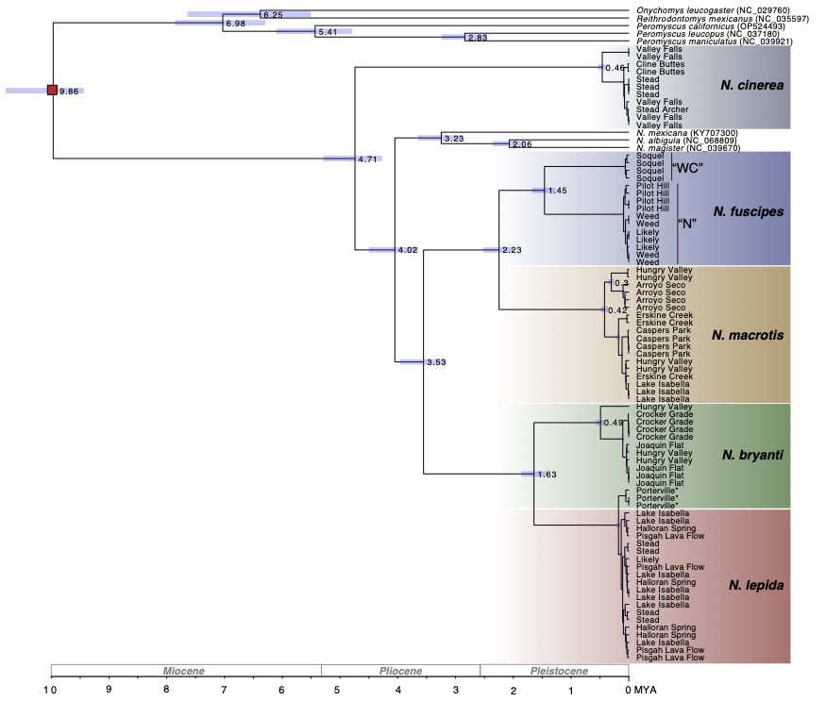

**Supplemental Figure 1**. A time-calibrated Bayesian phylogeny estimated using whole mitochondrial genome data in BEAST2. Nodes are labeled with median ages (in millions of years), with the light blue bars denoting 95% confidence intervals. The red square denotes the node that was calibrated using stratigraphic information from the fossil *Paronychomys*†. Tips from our five focal species are labeled according to collection locality. Additional tips on the tree were added using previously published data and are annotated with their GenBank accession numbers. Note that three individuals of *N. bryanti* from the Porterville locality (indicted by *) fall out within the *N. lepida* clade due to a known case of mitochondrial capture. Two clades within *N. fuscipes* (West-Central, “WC”, and North, “N”) are also labeled and discussed in the text.

**Data availability:**

Sequence data used in this study can be retrieved under NCBI PRJNA951688.

**Scripts used in this study:**

Overall steps**:**

1. Generate raw vcf with bcftools mpileup

2. Filter vcf with vcftools

3. Create a list of informative sites with bcftools (speeds up step 4)

4. Run angsd to generate input file for NGSadmix

5. Run NGSadmix to create opt file

6. Use R and Adobe Illustrator to generate charts from opt file

**Create VCF**

DIR=/Projects/Neotoma/60_LC_5sp/bam_links/Nb_ref_bams

OUTDIR=/Projects/Neotoma/60_LC_5sp/mpileup_out

LOGDIR=${OUTDIR}/logs

RUNDIR=$OUTDIR

REF=/Projects/Neotoma/References/Nbryanti_pseudoNm/Nbryanti_pseudoNm.fasta

OUTFILE=${OUTDIR}/Neo56_5sp_Nbry_ref.vcf.gz

LOG=${LOGDIR}/mpileup_call_Neo56_5species_Nbryref_112024.log

mkdir -p $OUTDIR $LOGDIR

bam_files=/Projects/Neotoma/60_LC_5sp/bam_links/Nb_ref_bams/*merged.bam

cd $DIR

# Execute the mpileup and call commands directly

bcftools mpileup -Ou -B -C 50 -a QS -a AD -a DP --threads 128 -f $REF $bam_files 2>$LOG | bcftools call -mv -Oz -a GQ --threads 128  -o $OUTFILE 2>>$LOG

**Filter VCF**

Neo_VCF_IN=Neo56_5sp_Nbry_ref.vcf.gz

Neo_VCF_OUT=filtered/Neo56_MD4MAF017M4Q30_filt.vcf.gz

# set filters

MAF=0.017

MISS=0.8

QUAL=30

MIN_DEPTH=4

MAX_DEPTH=30

# perform the filtering with vcftools

vcftools --gzvcf $Neo_VCF_IN \

--remove-indels --maf $MAF --max-missing $MISS --minQ $QUAL \

--min-meanDP $MIN_DEPTH --max-meanDP $MAX_DEPTH \

--minDP $MIN_DEPTH --maxDP $MAX_DEPTH --recode --stdout | gzip -c > \

$Neo_VCF_OUT

**Steps of Admixture Analyses**

1. Create a sites list from the filtered vcf file (saves significant compute time when running angsd)

bcftools query -f '%CHROM\t%POS\n' Neo56_MD4MAF017M4Q30_filt.vcf.gz > Neo56_MD4MAF017M4Q30_sites.txt

1. Index the sites list

angsd sites index Neo56_MD4MAF017M4Q30_sites.txt

1. Generate NGSadmix input file

angsd -bam Neo56_fullpath_final_order.txt -GL 2 -doMajorMinor 1 -doMaf 1 -SNP_pval 2e-6 -minMapQ 30 -minQ 20 -minInd 25 -minMaf 0.017 -doGlf 2 -sites Neo56_MD6MAF017M8Q20_sites.txt -out Neo56_MD4MAF017M4Q30 -P 8

1. Run NGSadmix

NGSadmix -likes Neo56_MD4MAF017M4Q30.beagle.gz -K 4 -P 8 -o Neo56_MD4Q30_k4 -minMaf 0.017

1. Plot results for Neo56 in R

# Load admixture data

q <- read.table("Neo56_MD4Q30_k4.qopt")

# Load the population and individual label mapping

pop_list <- read.table("pop_list_final.txt", header = FALSE, stringsAsFactors = FALSE)

colnames(pop_list) <- c("Population", "Individual")

# Load admixture data

q <- read.table("Neo56_MD4Q30_k4.qopt")

# Load the population and individual label mapping

pop_list <- read.table("pop_list_final.txt", header = FALSE, stringsAsFactors = FALSE)

colnames(pop_list) <- c("Population", "Individual")

# Define the desired population order

desired_order <- c("Nfuscipes", "Nmacrotis", "Nlepida", "Nbryanti", "Ncinerea")

# Create a custom ordering index

ord <- match(pop_list$Individual, unique(pop_list$Individual)) # Maintain original order of individuals

# Reorder populations

pop <- pop_list$Population[ord]

individual_labels <- pop_list$Individual[ord]

# Reorder individual labels

q <- q[ord, ]

# Create the PDF file

pdf("Neo56_MD4MAF017Q30_k4_fixed_pop.pdf", width = 12, height = 3.25)

# Generate the barplot and disable x-axis ticks

bar_positions <- barplot(t(q), col = 2:10, space = 0, border = NA, xlab = "", ylab = "Neo56 Admixture proportions for K=4", xaxt = "n")

# Add individual labels below each bar

text(bar_positions, par("usr")[3] - 0.01, labels = individual_labels, srt = 110, adj = 1, xpd = TRUE, cex = 0.65)

# Add population labels at group midpoints, in the specified order

group_midpoints <- tapply(bar_positions, factor(pop, levels = desired_order), mean)

text(group_midpoints, par("usr")[3] - 0.30, labels = desired_order, xpd = TRUE, cex = 1.0)

# Add vertical lines to separate groups

abline(v = cumsum(sapply(desired_order, function(x) sum(pop == x))), col = 1, lwd = 1.2)

# Save the PDF

dev.off()

Final admixture chart edited in Illustrator v.29.1