Morphological variation in Corynorhinus mexicanus

Evolutionary and environmental influences on cranial shape and forearm length variation in Corynorhinus mexicanus

Supplementary Data SD1. Map of sampling localities for individuals analyzed and results of sexual dimorphism analysis for forearm length and cranial and mandibular shapes.

Fig. S1. Distribution of sampling localities for individuals measured for forearm length.
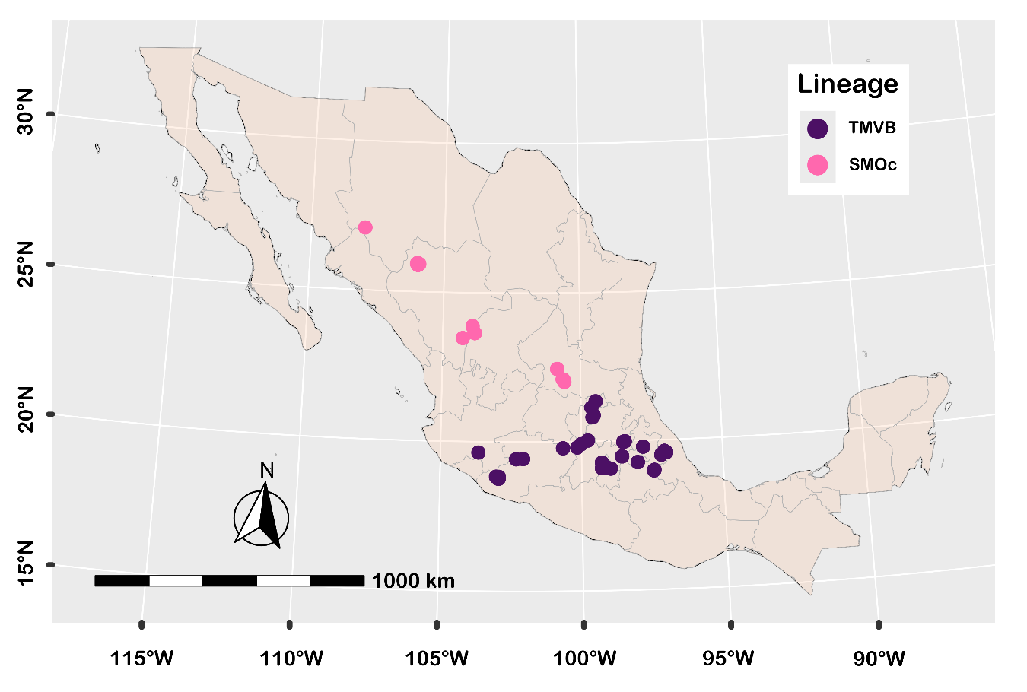

Fig. S2. Sexual dimorphism in forearm length of Corynorhinus mexicanus.
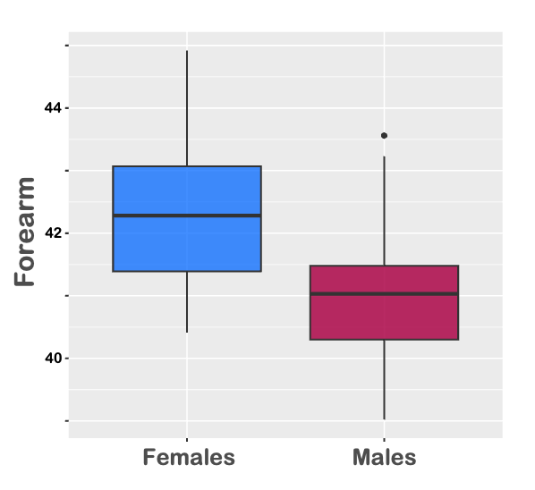

Table S1. Results of sexual dimorphism in cranial and mandibular shapes of Corynorhinus mexicanus based on Procrustes ANOVA. Sample sizes by sex are shown (♂ = males; ♀ = females). Significant effects of sex on shape for each module and view are indicated in bold.
Module/View | n | Factor | d.f. | SS | MS | R² | F | Z | P
Dorsal | ♂ = 46 | Sex | 1 | 0.0003 | 0.0003 | 0.0212 | 2.2276 | 1.8986 | 0.023
 | ♀ = 59 | Residuals | 103 | 0.0131 | 0.0001 | 0.9788
 |  | Total | 104 | 0.0134
Lateral | ♂ = 49 | Sex | 1 | 0.0020 | 0.0020 | 0.0255 | 2.7742 | 2.5023 | 0.01
Braincase | ♀ = 59 | Residuals | 106 | 0.0749 | 0.0007 | 0.9745
 |  | Total | 107 | 0.0768
Lateral | ♂ = 49 | Sex | 1 | 0.0017 | 0.0017 | 0.0146 | 1.5662 | 1.0266 | 0.143
Rostrum | ♀ = 59 | Residuals | 106 | 0.1150 | 0.0011 | 0.9854
 |  | Total | 107 | 0.0117
Ventral | ♂ = 46 | Sex | 1 | 0.0007 | 0.0007 | 0.0104 | 1.0361 | 0.2774 | 0.41
Braincase | ♀ = 55 | Residuals | 99 | 0.0663 | 0.0007 | 0.9896
 |  | Total | 100 | 0.0670
Ventral | ♂ = 46 | Sex | 1 | 0.0011 | 0.0011 | 0.0131 | 1.3171 | 0.7375 | 0.233
Rostrum | ♀ = 55 | Residuals | 99 | 0.0797 | 0.0008 | 0.9869
 |  | Total | 100 | 0.0808
Mandible | ♂ = 46 | Sex | 1 | 0.0004 | 0.0004 | 0.0066 | 0.6430 | -0.7559 | 0.755
 | ♀ = 53 | Residuals | 97 | 0.0528 | 0.0005 | 0.9934
 |  | Total | 98 | 0.0532

Fig. S3. Dorsal (A) and lateral braincase (B) shape variation in male and female Corynorhinus mexicanus, visualized with a magnification factor (“mag = 5”) for clarity. Histograms display Linear Discriminant Function scores highlighting shape differentiation between sexes.
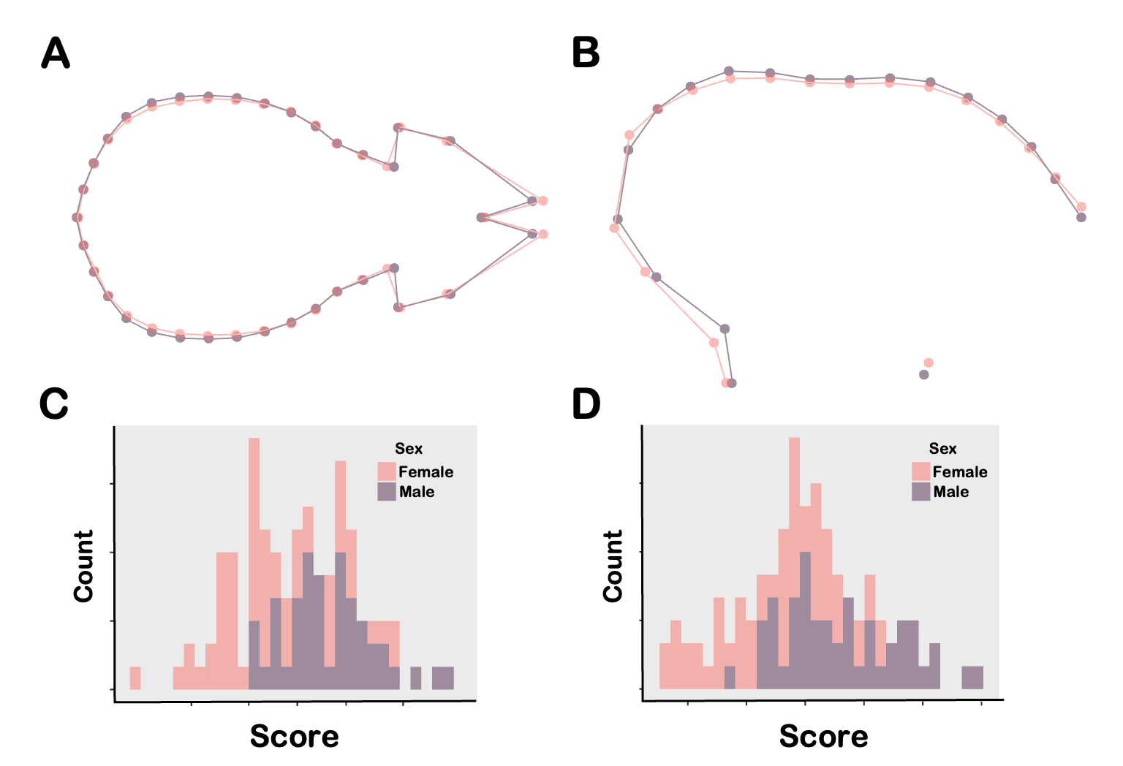
Table S4. Linear model results for sexual dimorphism in centroid size across cranial and mandibular modules and views of Corynorhinus mexicanus. Sample sizes by sex (♂ = males; ♀ = females) and significant effects are shown in bold.
Module/View | Factor | n | d.f. | SS | MS | R² | F | Z | P
Dorsal | Sex | ♂ = 46 | 1 | 0.106 | 0.10637 | 0.00166 | 0.1708 | -0.47257 | 0.665
 | Residuals | ♀ = 59 | 103 | 64.154 | 0.62285 | 0.99834
 | Total |  | 104 | 64.260
Lateral | Sex | ♂ = 49 | 1 | 0.084 | 0.08421 | 0.00435 | 0.4634 | 0.057219 | 0.493
Braincase | Residuals | ♀ = 59 | 106 | 19.261 | 0.18171 | 0.99565
 | Total |  | 107 | 19.345
Lateral | Sex | ♂ = 49 | 1 | 0.2713 | 0.271281 | 0.04515 | 5.0127 | 1.9222 | 0.017
Rostrum | Residuals | ♀ = 59 | 106 | 5.7366 | 0.054118 | 0.95485
 | Total |  | 107 | 6.0078
Ventral | Sex | ♂ = 46 | 1 | 0.00009874 | 0.000099 | 0.05550 | 5.8172 | 2.0560 | 0.013
Braincase | Residuals | ♀ = 55 | 99 | 0.00168049 | 0.000017 | 0.94450
 | Total |  | 100 | 0.00177923
Ventral | Sex | ♂ = 46 | 1 | 0.00000241 | 0.000002 | 0.00159 | 0.1576 | -0.6094 | 0.724
Rostrum | Residuals | ♀ = 55 | 99 | 0.00151135 | 0.000053 | 0.99841
 | Total |  | 100 | 0.00151376
Mandible | Sex | ♂ = 46 | 1 | 6.6691 | 6.6691 | 0.22354 | 27.9260 | 3.5977 | 0.001
 | Residuals | ♀ = 53 | 97 | 23.1648 | 0.2388 | 0.77646
 | Total |  | 98 | 29.8339

Fig. S5. Sexual dimorphism in centroid size across cranial and mandibular modules and views. Female-biased variation is observed in the mandible and lateral rostrum, whereas male-biased variation occurs in the ventral braincase.
